**Compiled By,**

**Mohit Mittal,**

**Sneha Ravikumar,**

**Taj Poovaiah**

**NYC YELLOW TAXI DATA ANALYSIS REPORT- Team 7**

Contents

pipeline: 4

STEPS TO RUN THE Pipeline 4

DATA PREPROCESSING: 5

**Deployment** 5

Prediction for Fare Amount 6

FARE AMOUNT MIN AND MAX VALUES IN THE ENTIRE DATA-SET 6

OVERVIEW 7

AZURE PREDICTION MODEL & web service model FOR FARE AMOUNT PREDICTION 8

Selecting columns in Dataset 11

Fine Tuning 1 11

Feature Selection 11

MICROSIFT AZURE EXPERIMENTS 13

NEURAL NETWORK 13

Decision Forest Regression Algorithm 16

Boosted Decision Tree: 19

Linear Regression: 21

Fine Tuning 2 24

Decision Tree Based Algorithm: 25

Boosted Decision Tree Algorithm 27

Scored Model: 27

Linear Regression: 28

Neural Network: 29

Fine Tuning 3 30

**Decision Forest Regression Algorithm** 31

Boosted Decision Tree Algorithm: 32

Linear Regression 33

Neural Network 35

FINE TUNING 4 38

FINE TUNING 5 40

The chosen one 40

Web Service azure model 41

azure mACHINE LEARNING EXPERIMENTS 42

IMPORT & COMBINE DATA 42

HEURISTICS BASED FEATURE SELECTION 43

Filter Based Feature Selection 43

10 columns 45

Two Algorithms 45

evaluation 46

15 COLUMNS 47

how many columns to choose? 47

Fine tuning 48

**Classification** 49

Data Analysis Using Jupyter Notebook 51

NYC TAXI (YELLOW) TRIPS – PICK-UP AND DROP-OFF 51

Conclusions 51

NYC TAXI (YELLOW) TRIPS – tip and total amount data 52

Conclusions 52

TAXI RIDES AGAINST EXTREME WEATHER CONDITIONS (MAY AND JUNE 2016) 53

CONCLUSIONS 55

FARE AMOUNT, TRIPTIME, PASSENGER COUNT USING CARTO MAPS 55

CONCLUSIONS 56

FARE AMOUNT, TRIPTIME, PASSENGER COUNT USING CARTO MAPS 57

CONCLUSIONS 57

TRIP-TIME USING CARTO 58

CONCLUSIONS 58

WEATHER CONDITIONS USING CARTO 59

CONCLUSIONS 59

TRIP-DISTANCE 60

CONCLUSIONS 60

CLASSIFIED AREAS USED FOR PREDICTING BUSIEST AREAS FOR DRIVERS 61

CONCLUSIONS 61

CLASSIFIED AREAS USED FOR PREDICTING BUSIEST AREAS FOR DRIVERS 62

CONCLUSIONS 62

TIP AMOUNT HOT-SPOTS USING ARCGIS (2015 data) 62

CONCLUSIONS 63

CONCLUSIONS 64

DEMO OUTPUTS 65

# pipeline:

**Programming Language used : Python**

**Workflow Manager User: Luigi**

**Tasks**

1. **Downloading Loan Data (GetData.py)**
2. **Clean Loan Data (CleanData.py)**
3. **Cleaned Driver Data (CleanDriverData.py)**
4. **Upload Preprocessed data to Amazon S3 (LoanData.py)**

# STEPS TO RUN THE Pipeline

1. Pull the Docker image (mohit914/ads_final:v1.02) from the Docker hub

**docker pull mohit914/ads_final:v1.02**

1. Run the Docker image. It will take you into the bash terminal

**docker run -ti mohit914/ads_final:v1.02**

1. Inside the bash terminal run the python application by using the following command

**python Start.py Start –local-scheduler**

This program will run the following tasks automatically:

1. **GetData()** – It will download the NYC yellow taxi dataset for Jan-June 2016
2. **ClenaData()** – It will clean and preprocess the taxi dataset and join weather data for fare amount and trip time
3. **CleanDriverData() –** It will clean and preprocess the data and join weather data for prediction of location of maximum pickups
4. **Start()** – It will upload the preprocessed data to Amazon S3 Bucket. ***You will need to provide your Amazon Access key and Secret Key to complete this task.***

***Docker Trouboulshooting:***

* + - 1. *If running docker gives No space on the device error, then remove all the images and follow the steps to run the pipeline again. If problem still exists, remove all the images and containers on your device and follow the steps to run the pipeline again.*
      2. *You will need to increase your image memory to 4 GB and space to 30 GB for the pipeline to work.*
      3. *If the problem still exists, please email us to let us know the problem so that we can try to troubleshoot the problem.*

# DATA PREPROCESSING:

**Data Dictionary**: <http://www.nyc.gov/html/tlc/downloads/pdf/data_dictionary_trip_records_yellow.pdf>

**The following changes were made to the original dataset:**

* The following columns were irrelevant to our analysis & hence dropped

'extra', 'mta_tax','tip_amount',"tolls_amount","improvement_surcharge","total_amount", "payment_type", "store_and_fwd_flag", “vendor_ID”

* Split the Date-Time column to create four individual columns – PickupDate, PickupTime, DropoffDate, DropoffTime
* Derived columns to indicate Day Of week (0-6) and if it’s a working day or not
* Removed all Passerget_count rows which had over 8 or zero passesngers
* Removed rows with elapsed trip time as zero
* Remove all trips that have distance zero and price above $5 (679 rows off 200,000)
* Removed trips with negative charges
* Precision of the Latitudes and the Longitudes describes the range of area covered. We created extra columns with different range of precision to tackle our prediction and classification algorithms differently
* Removed rows where the co-ordinates went beyond NYC bored
* Removed triptime > 3 hours

# **Deployment**

Web Interface (Frontend)

Web Application

(Backend)

Classification REST API

(MAX PICKUP LOCATION)

Prediction REST API 1

(Fare Amount)

Prediction REST API 2

(TripTime/ETA)

1. **Web Interface** (**HTML, Javascript, JQuery, CSS, Bootstrap**)
2. Takes the input and shows the fare amount and trip time for riders
3. Takes the input and shows the location for maximum pickups for drivers
4. Link to Visualizations, Jupyter notebook visualization
5. Link to PPT and Report
6. **Web Application (Backend: Java)** –

Application (Using Java to interacts with the frontend and the 3 rest apis (1 Classification, 2 Prediction). Hosting on AWS

1. **REST API on Azure ML Studio**

**Account:** [team7ads@outlook.com](mailto:team7ads@outlook.com)

**Password: ADSfinalteam7**

*The account contains all the experiments for classification part and only the selected experiment for predicting fare amount and trip time(ETA). We have only the selected experiment in this account (and only on a month’s data) because these experiments were done on the data size of approx. 17 GB so, we did those experiments on our personal accounts and the APIs are also built on our personal accounts.*

# Prediction for Fare Amount

## FARE AMOUNT MIN AND MAX VALUES IN THE ENTIRE DATA-SET

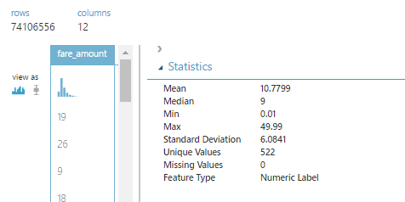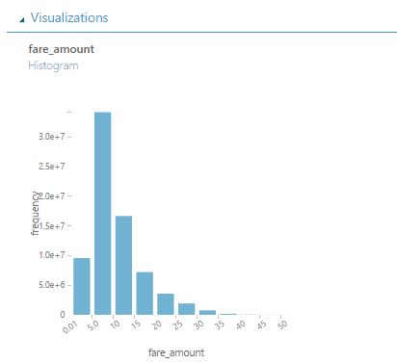

## OVERVIEW

FEATURE SELECTION

SELECTED COLUMNS

LINEAR REGRESSION

NEURAL NETWORK REGRESSION

DECISION TREE REGRESSION

BOOSTED DECISION TREE REGRESSION

# AZURE PREDICTION MODEL & web service model FOR FARE AMOUNT PREDICTION

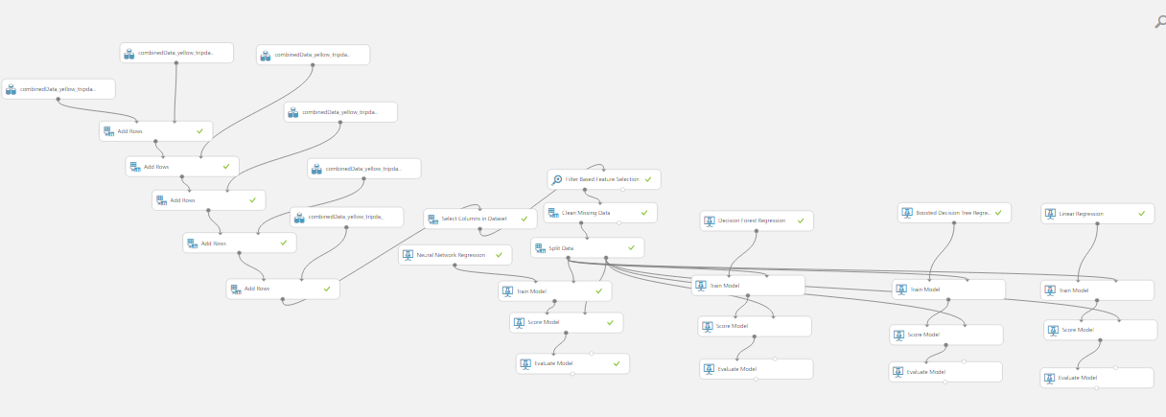

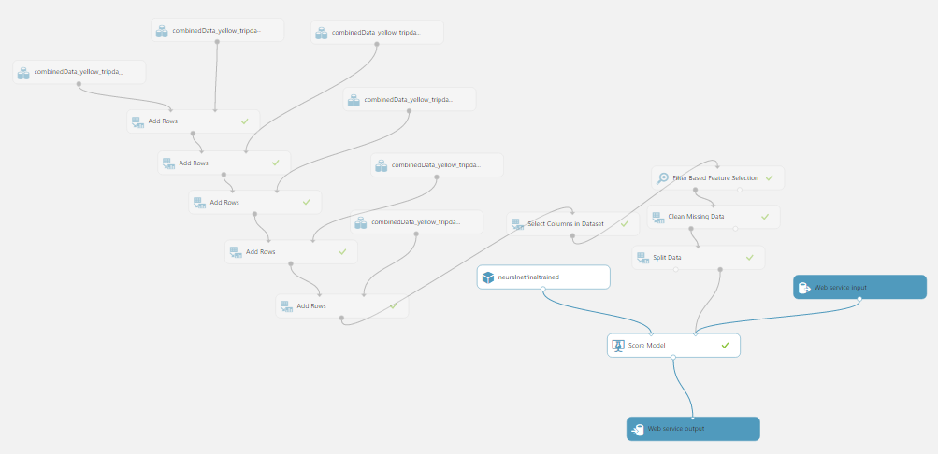

* 16 Columns , with all features ranked except trip-time (due to direct correlation)

|  |  |  |  |  |
| --- | --- | --- | --- | --- |
|  | Linear Regression  Algorithm | Decision Tree Algorithm | Boosted Decision Tree Algorithm | Neural Network  Algorithm |
| MAE | **1.457913** | **1.283841** | **1.242083** | **1.216927** |
| RMSE | **2.087011** | **1.891298** | **1.826295** | **1.803673** |
| RAE | **0.31874** | **0.280683** | **0.271554** | **0.266054** |
| Relative Squared Error | **0.119561** | **0.098188** | **0.091555** | **0.089301** |
| Coefficient Of Determination | **0.880439** | **0.901812** | **0.908445** | **0.910699** |

* 16 columns, with all features ranked except trip-time and trip-distance (direct correlation)

|  |  |  |  |  |
| --- | --- | --- | --- | --- |
|  | Linear Regression  Algorithm | Decision Tree Algorithm | Boosted Decision Tree Algorithm | Neural Network  Algorithm |
| MAE | **1.457778** | **1.280107** | **1.242451** | **1.212999** |
| RMSE | **2.086805** | **1.886798** | **1.825607** | **1.820459** |
| RAE | **0.31871** | **0.279867** | **0.271634** | **0.265195** |
| Relative Squared Error | **0.119537** | **0.097721** | **0.091486** | **0.090971** |
| Coefficient Of Determination | **0.880463** | **0.902279** | **0.908514** | **0.909029** |

* 11 columns, with all features ranked except trip-time, trip-distance, drop-off time (direct correlation)

|  |  |  |  |  |
| --- | --- | --- | --- | --- |
|  | Linear Regression  Algorithm | Decision Tree Algorithm | Boosted Decision Tree Algorithm | Neural Network  Algorithm |
| MAE | **4.376378** | **1.782891** | **1.971312** | **1.68931** |
| RMSE | **5.770507** | **2.550868** | **2.76317** | **2.382844** |
| RAE | **0.949406** | **0.386778** | **0.427654** | **0.366477** |
| Relative Squared Error | **0.900342** | **0.175936** | **0.20644** | **0.153522** |
| Coefficient Of Determination | **0.099658** | **0.824064** | **0.79356** | **0.846478** |

FINE TUNING

(Hyper-parameters)

BEST MODEL

* We chose Neural Network as the best model and fine-tuned it to give a better rmse
* The below table illustrates the decrease in rmse with the increase in the number of hidden nodes
* Increasing the learning rate increased the rmse value
* We then decreased the learning rate, and increased the number of hidden nodes to get the best rmse out of the rest

|  |  |  |  |  |
| --- | --- | --- | --- | --- |
|  | Neural Network 1 | Neural Network 2 | Neural Network 3 | Neural Network 4 |
| Number of learning iterations | **100** | **100** | **100** | **100** |
| Number of hidden nodes | **100** | **200** | **300** | **400** |
| Learning Rate | **0.005** | **0.005** | **0.007** | **0.004** |
| RMSE | **2.382844** | **2.37906** | **2.426789** | **2.315834** |

# Selecting columns in Dataset

# Fine Tuning 1

* We first removed Trip Distance since it was directly correlated to Fare Amount
* We got the below columns ranked using the feature selector feature on Microsoft Azure

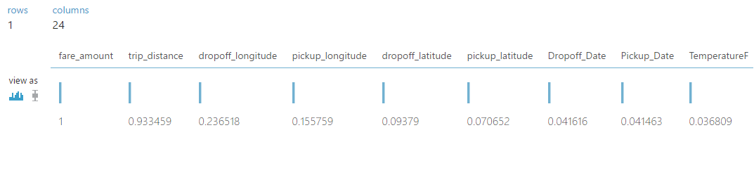

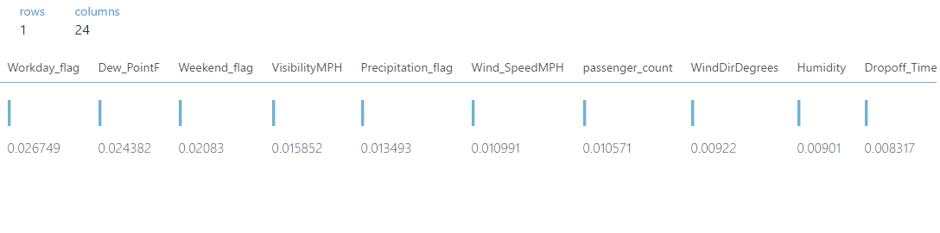

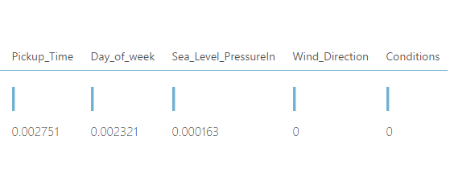

# Feature Selection

* We Used the Filter Based Feature Selection which ranked the features. We selected the first 15 features based on rank
* It clearly shows that the last few columns aren’t of any significance
* We first ran the experiment by selecting 15 columns
* Split Data: 0.8 to Train Model

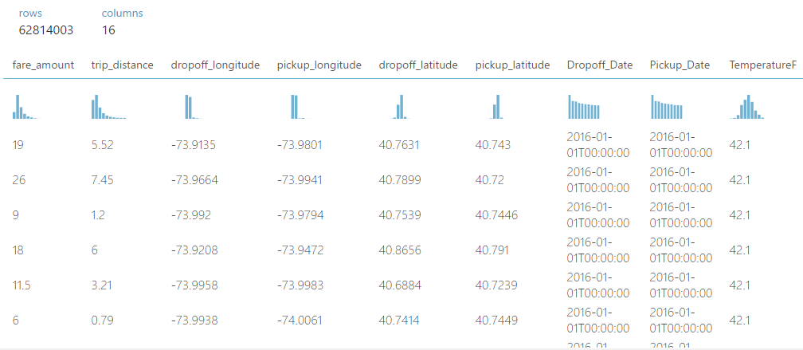

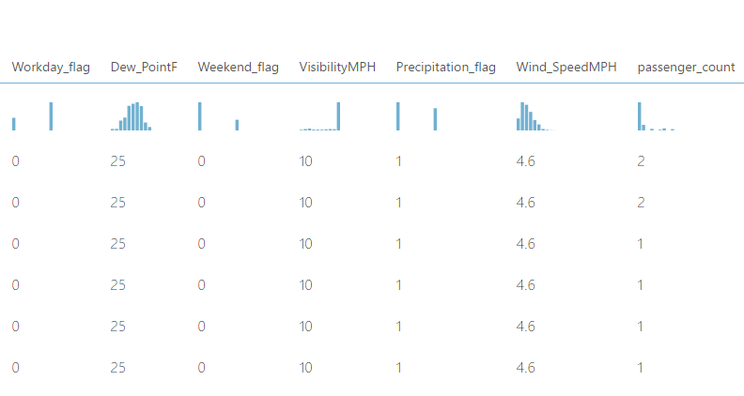

# MICROSIFT AZURE EXPERIMENTS

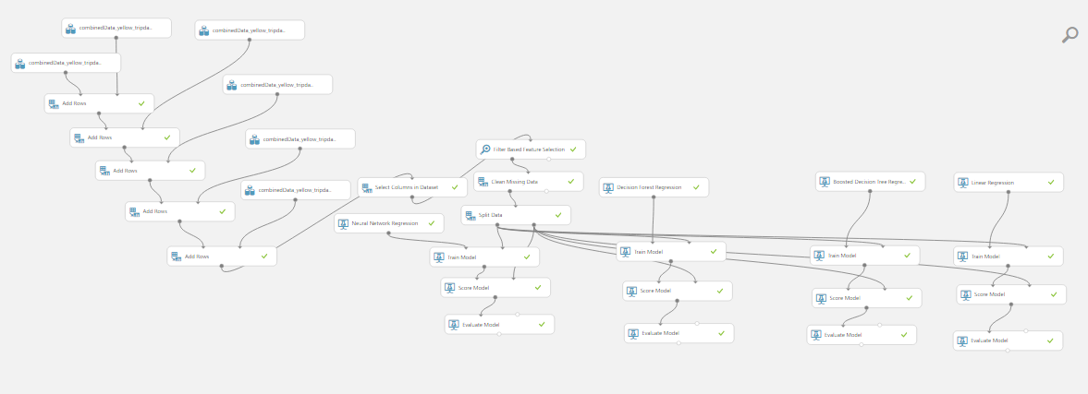

* We are using 4 algorithms for the prediction

1. Neural Network Algorithm
2. Decision tree Algorithm
3. Boosted Decision Tree Algorithm
4. Linear Regression Algorithm

## NEURAL NETWORK

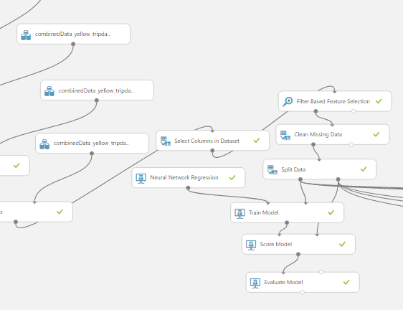

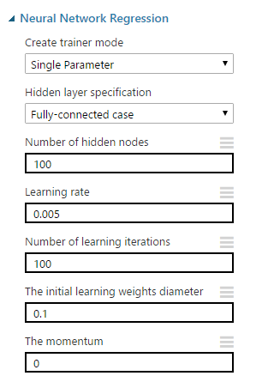

**Evaluated Model:**

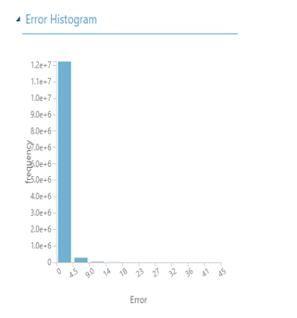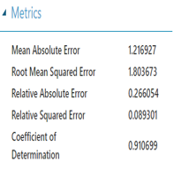

**Scored Model:**

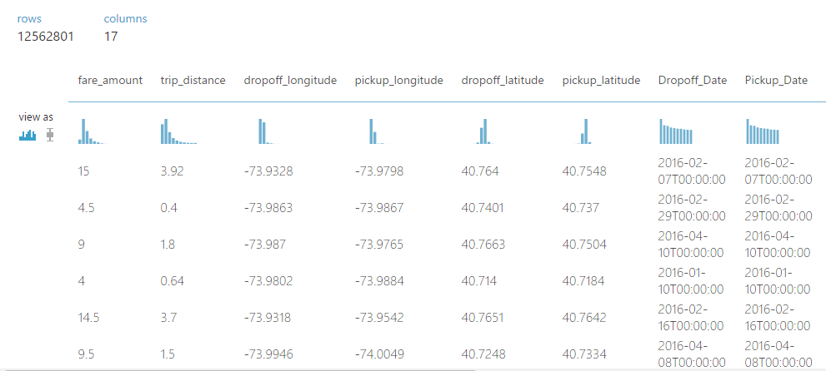

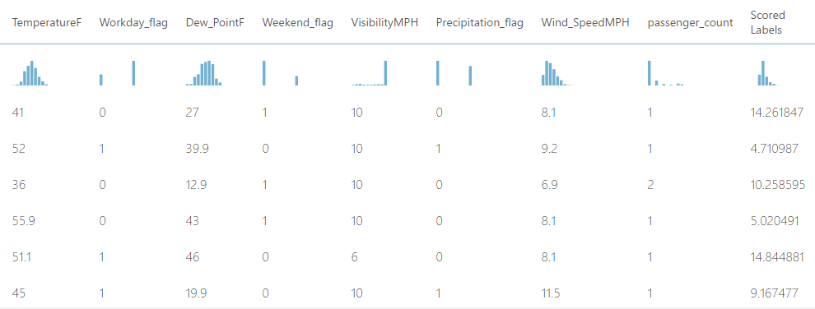

## Decision Forest Regression Algorithm

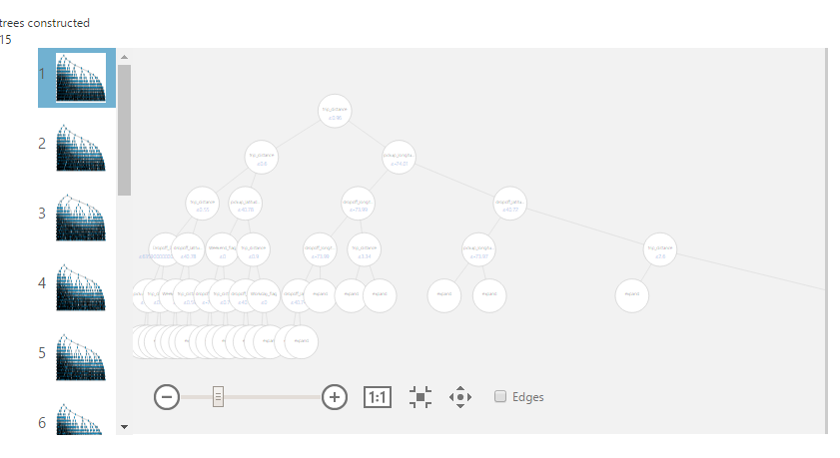

**Scored Model:**

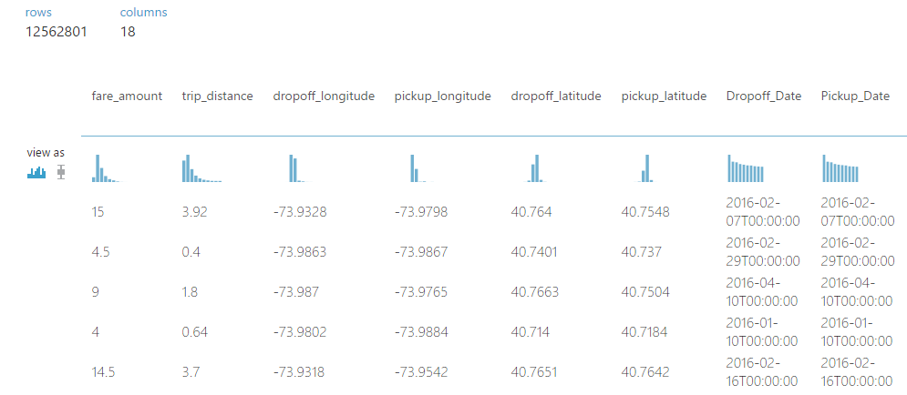

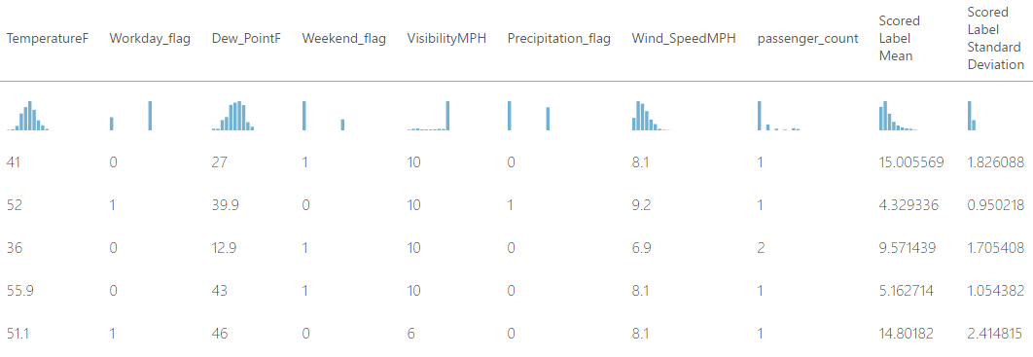

**Evaluated Model:**

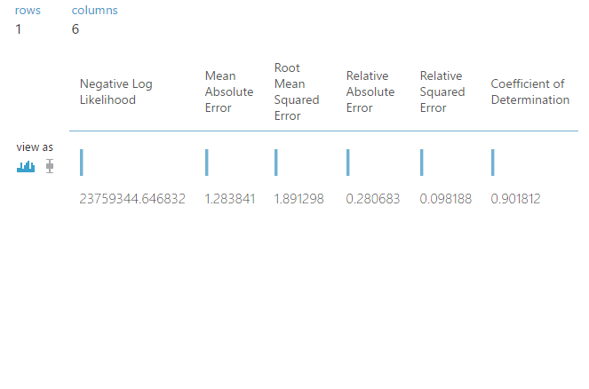

## Boosted Decision Tree:

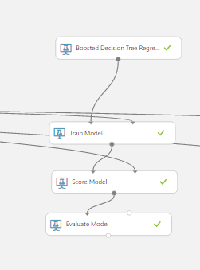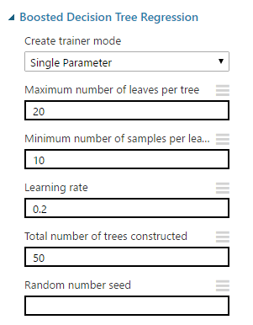

**Score Model:**

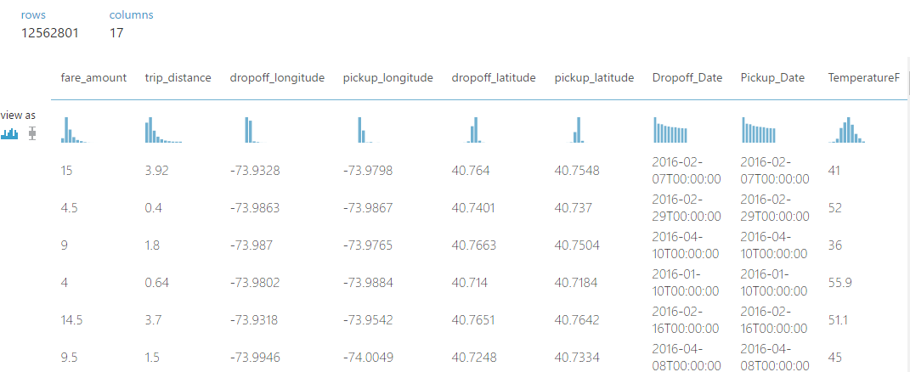

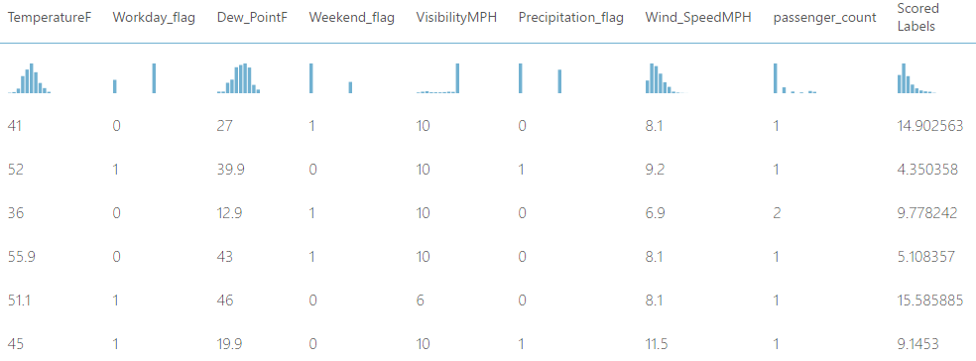

**Evaluated Model:**

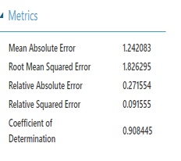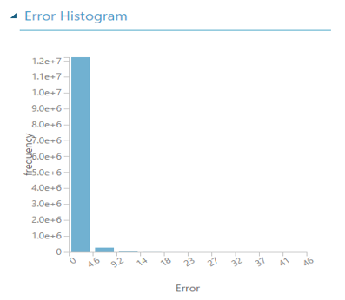

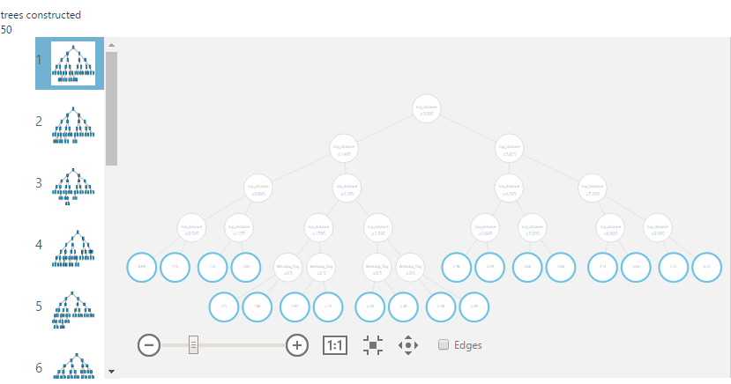

## Linear Regression:

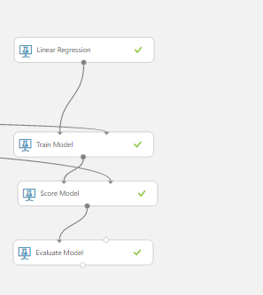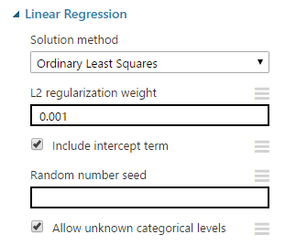

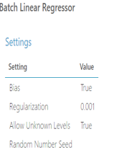

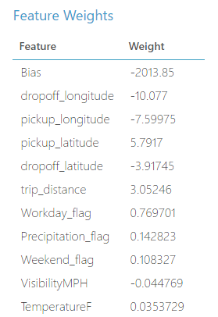

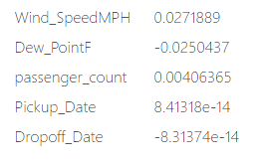

**Score Model:**

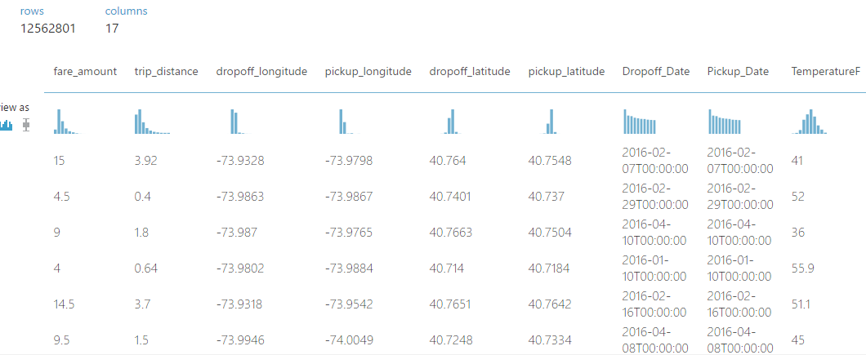

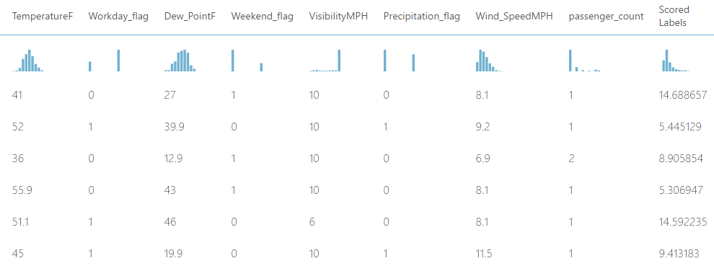

**Evaluated Model:**

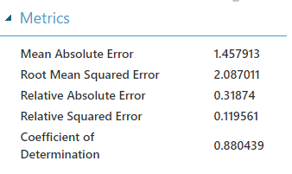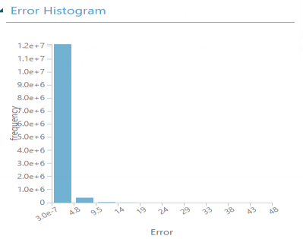

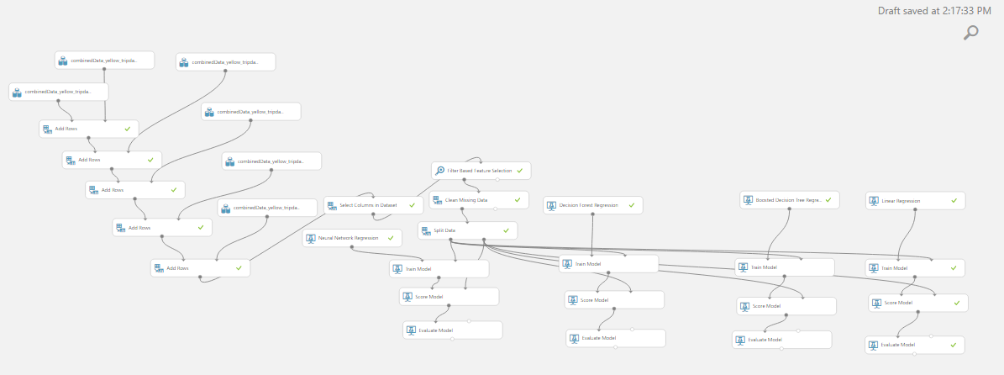

|  |  |  |  |  |
| --- | --- | --- | --- | --- |
|  | Linear Regression  Algorithm | Decision Tree Algorithm | Boosted Decision Tree Algorithm | Neural Network  Algorithm |
| MAE | **1.457913** | **1.283841** | **1.242083** | **1.216927** |
| RMSE | **2.087011** | **1.891298** | **1.826295** | **1.803673** |
| RAE | **0.31874** | **0.280683** | **0.271554** | **0.266054** |
| Relative Squared Error | **0.119561** | **0.098188** | **0.091555** | **0.089301** |
| Coefficient Of Determination | **0.880439** | **0.901812** | **0.908445** | **0.910699** |

# Fine Tuning 2

1. Neural Network gave the best rmse
2. We then Removed **Drop –Off time**, due to the Direct Correlation to **Fare Amount**
3. Used the Filter Based Feature Selection and selected 15 columns based on rankings

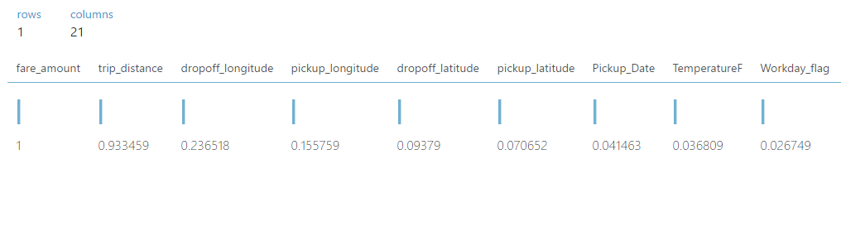

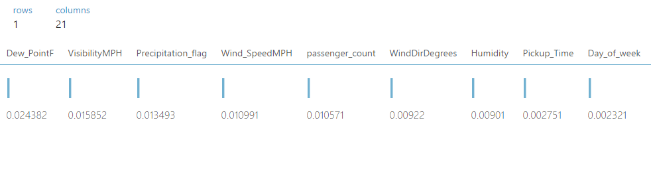

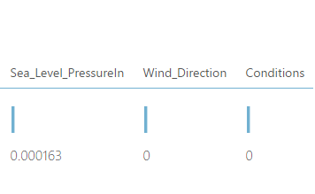

## Decision Tree Based Algorithm:

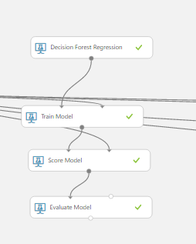 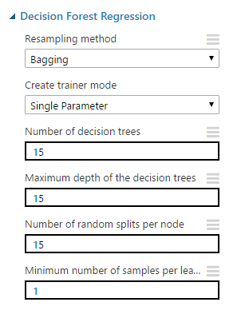

Scored Model:

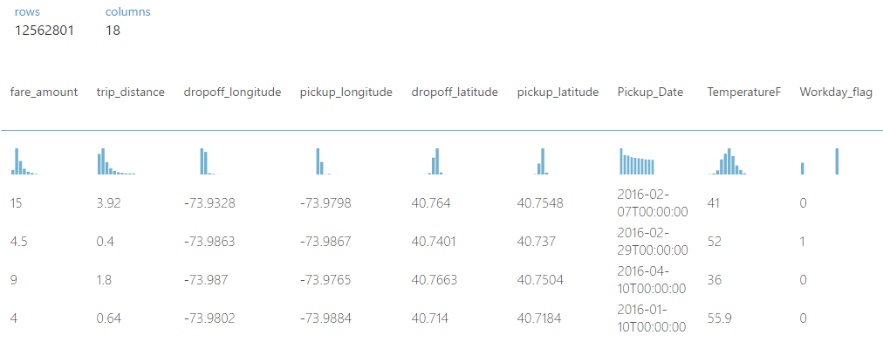

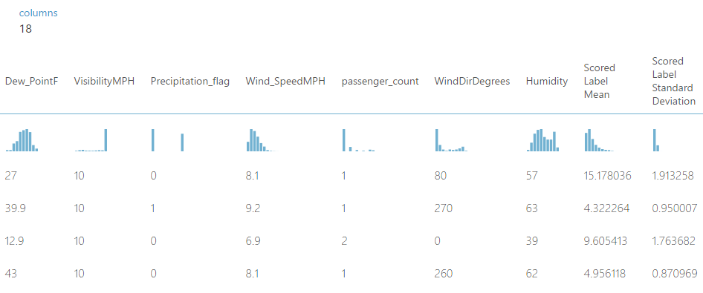

Evaluated Model:

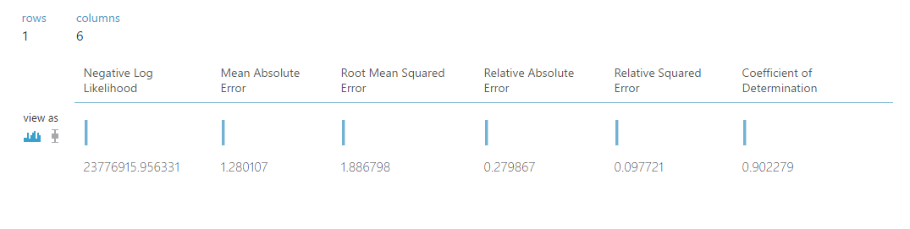

## Boosted Decision Tree Algorithm

## Scored Model:

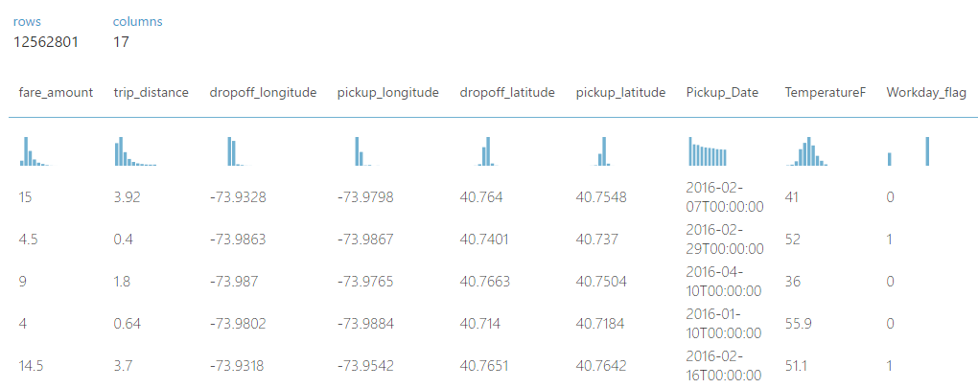

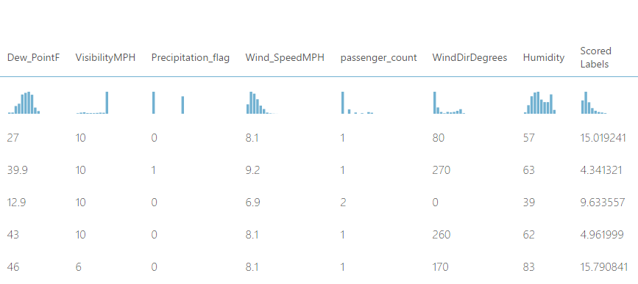

**Evaluated Model:**

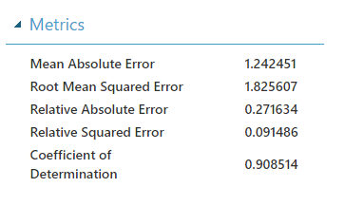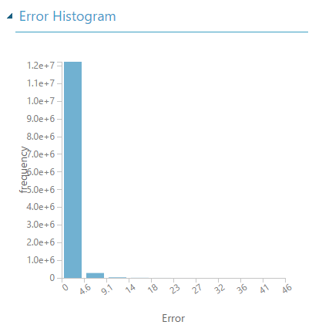

## Linear Regression:

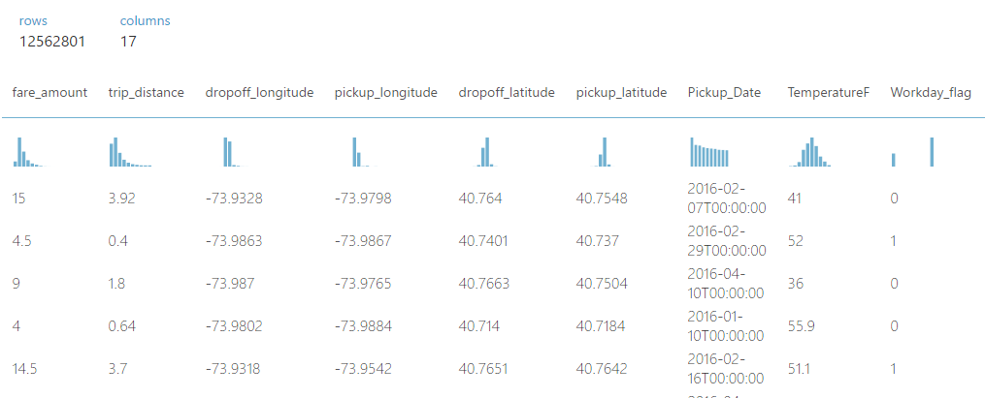

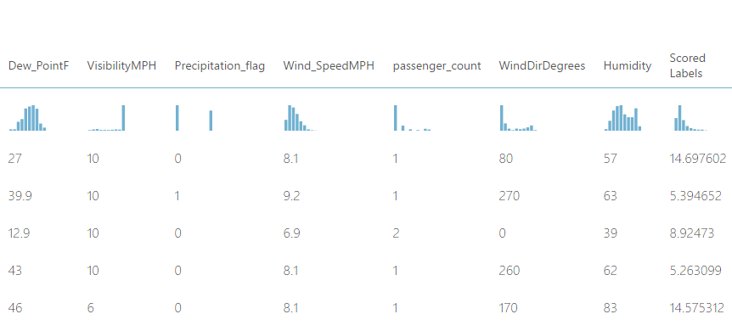

Evaluated Model:

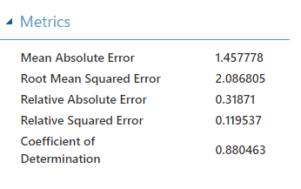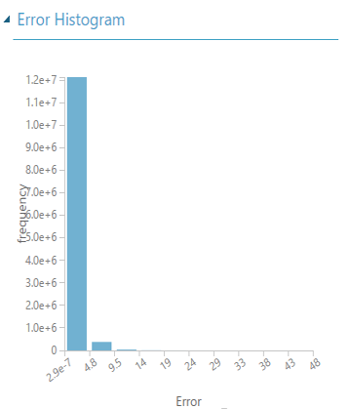

## Neural Network:

**Scored Model:**

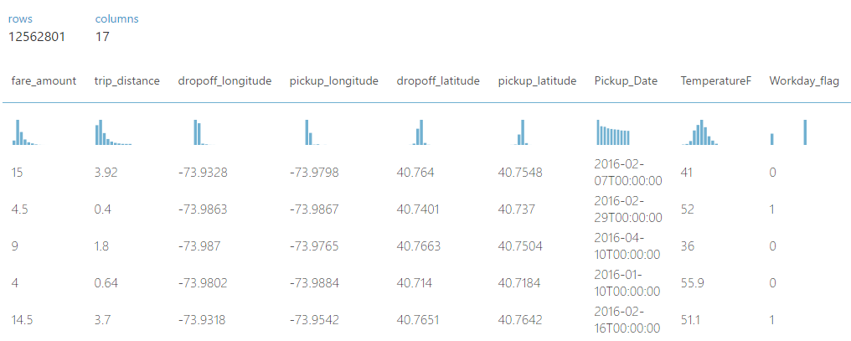

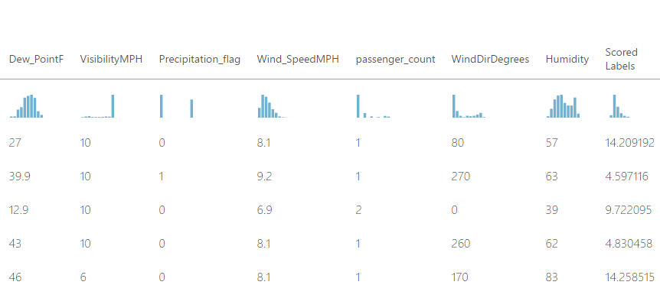

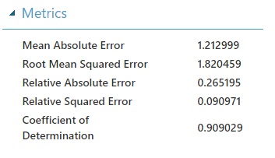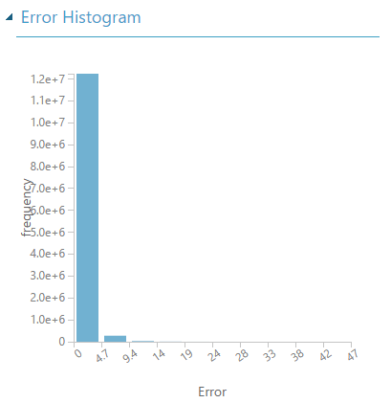

|  |  |  |  |  |
| --- | --- | --- | --- | --- |
|  | Linear Regression  Algorithm | Decision Tree Algorithm | Boosted Decision Tree Algorithm | Neural Network  Algorithm |
| MAE | **1.457778** | **1.280107** | **1.242451** | **1.212999** |
| RMSE | **2.086805** | **1.886798** | **1.825607** | **1.820459** |
| RAE | **0.31871** | **0.279867** | **0.271634** | **0.265195** |
| Relative Squared Error | **0.119537** | **0.097721** | **0.091486** | **0.090971** |
| Coefficient Of Determination | **0.880463** | **0.902279** | **0.908514** | **0.909029** |

# Fine Tuning 3

* We then removed Trip Distance and ran the 4 algorithms
* 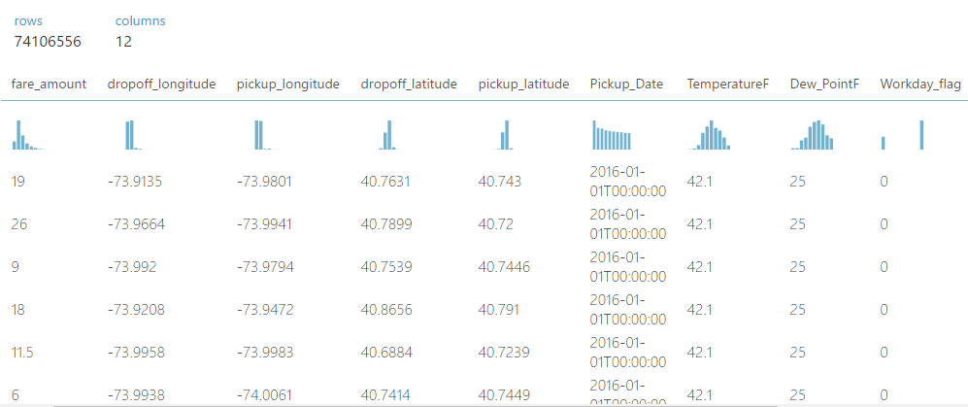

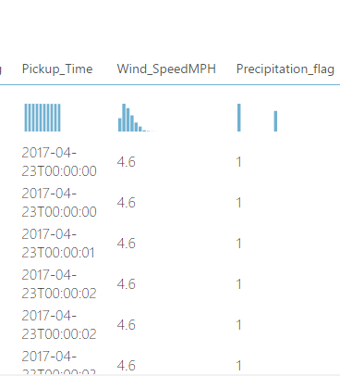

## **Decision Forest Regression Algorithm**

**Evaluated Model:**

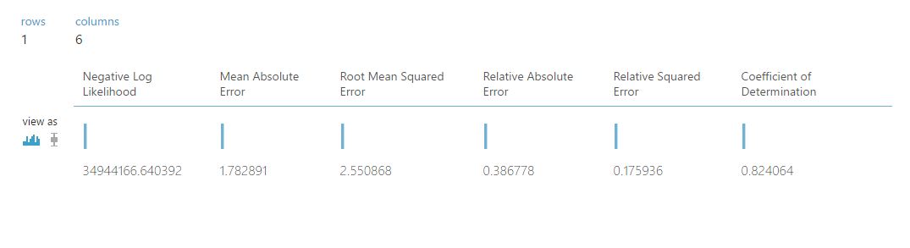

**Scored Model:**

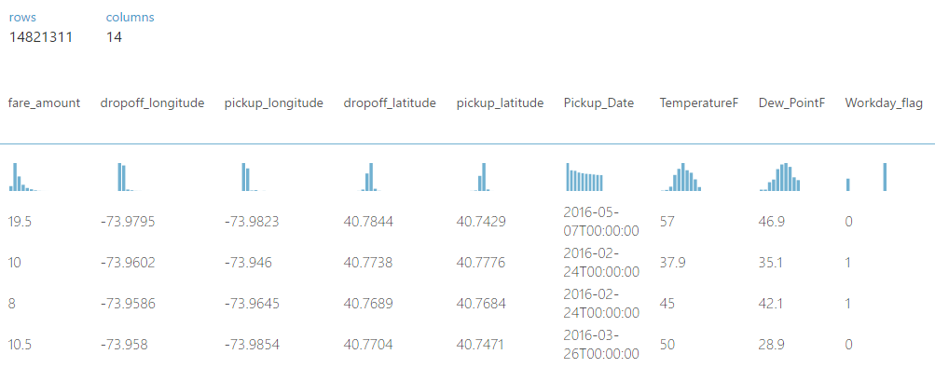

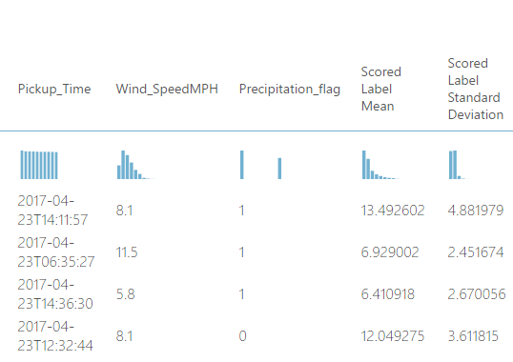

## Boosted Decision Tree Algorithm:

**Evaluated Model:**

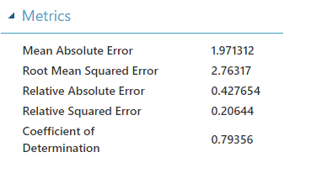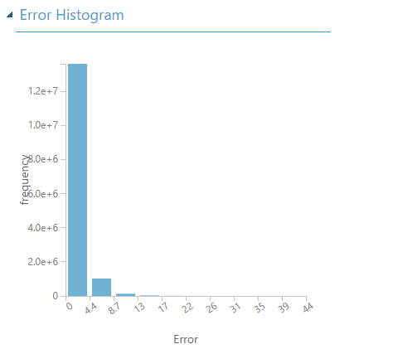

**Scored Model:**

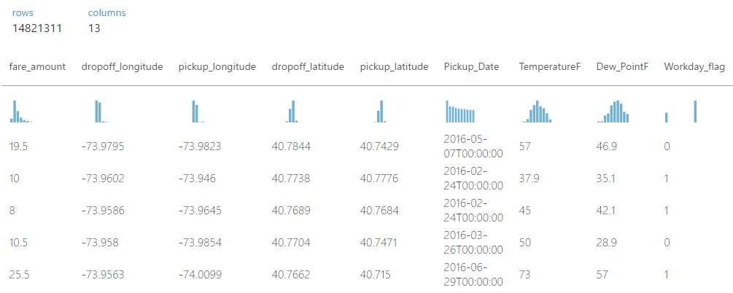

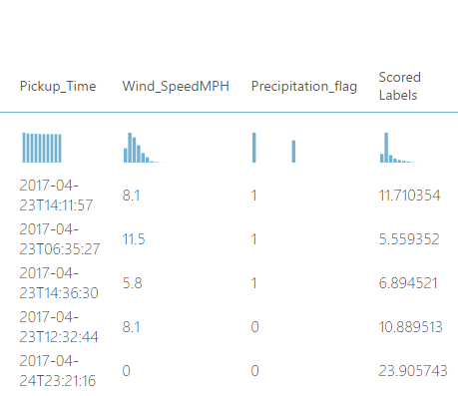

## Linear Regression

**Evaluated Model:**

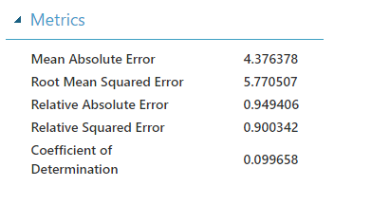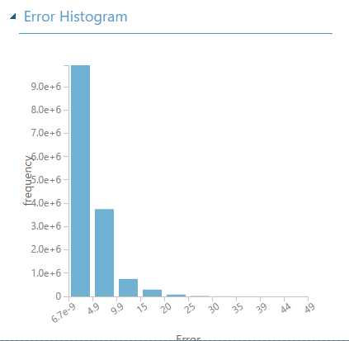

**Scored Model:**

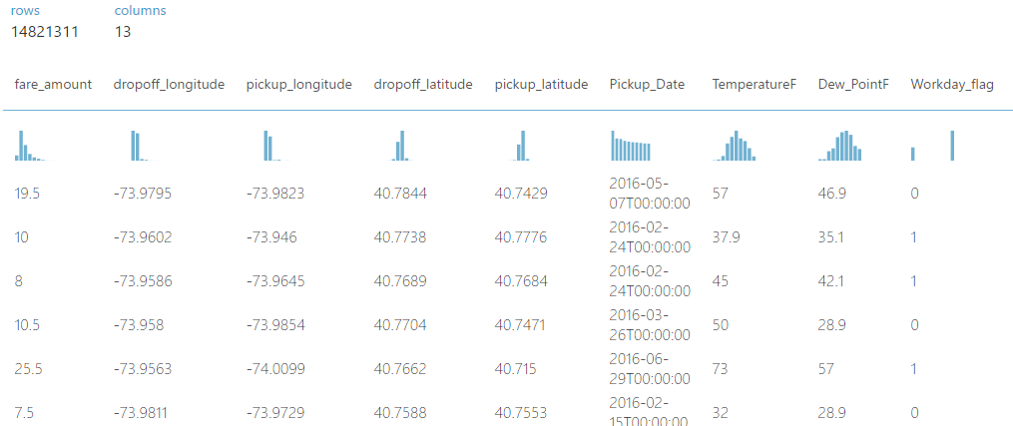

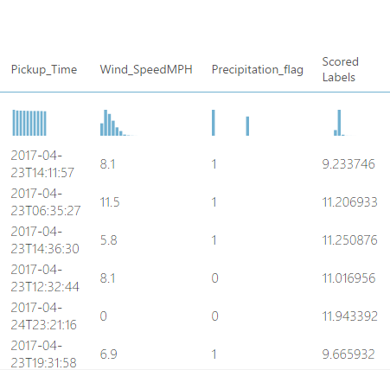

**Trained Model:**

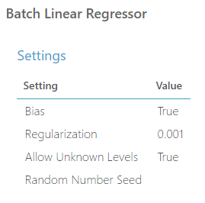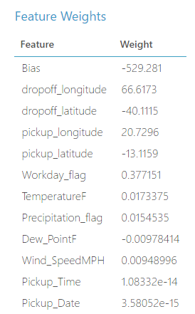

## Neural Network

**Scored Model:**

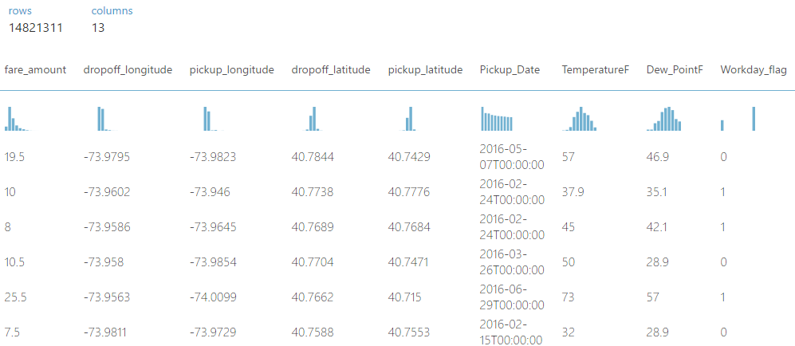

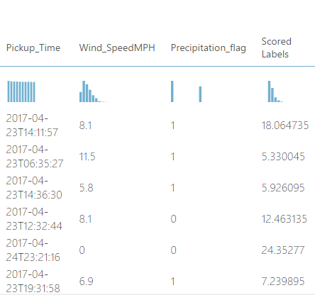

**Evaluated Model:**

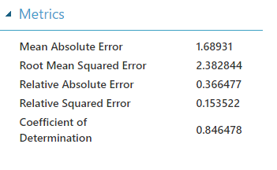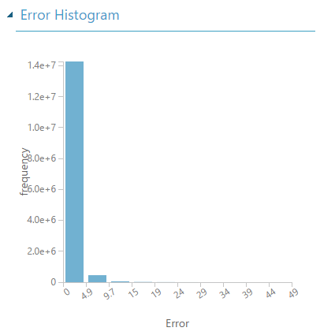

**Trained Model:**

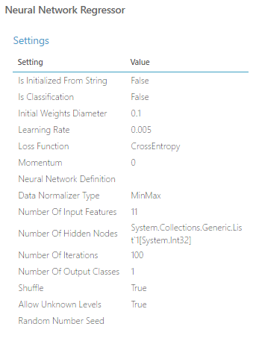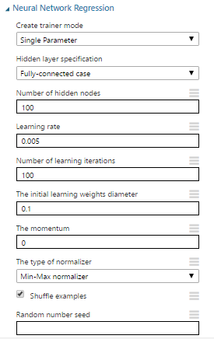

|  |  |  |  |  |
| --- | --- | --- | --- | --- |
|  | Linear Regression  Algorithm | Decision Tree Algorithm | Boosted Decision Tree Algorithm | Neural Network  Algorithm |
| MAE | **4.376378** | **1.782891** | **1.971312** | **1.68931** |
| RMSE | **5.770507** | **2.550868** | **2.76317** | **2.382844** |
| RAE | **0.949406** | **0.386778** | **0.427654** | **0.366477** |
| Relative Squared Error | **0.900342** | **0.175936** | **0.20644** | **0.153522** |
| Coefficient Of Determination | **0.099658** | **0.824064** | **0.79356** | **0.846478** |

* We got the above values after the various steps of fine tuning and feature selection
* The rmse value was for Neural Network
* We further fine-tuned the prediction by choosing and Neural Networks and changing the hyper parameters to get the best results
* We first used the default values of 100 hidden nodes and a learning rate of 0.005
* We then changes the values to 200 hidden nodes and a learning rate of 0.005
* We observed the below results

**Evaluated Model:**

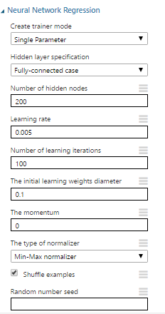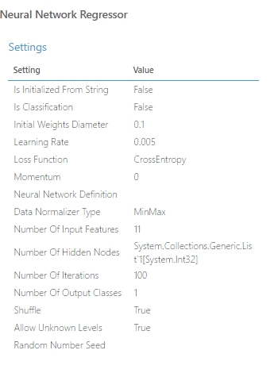

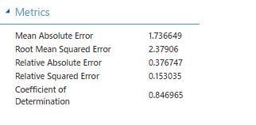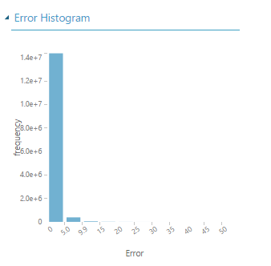

**Scored Model:**

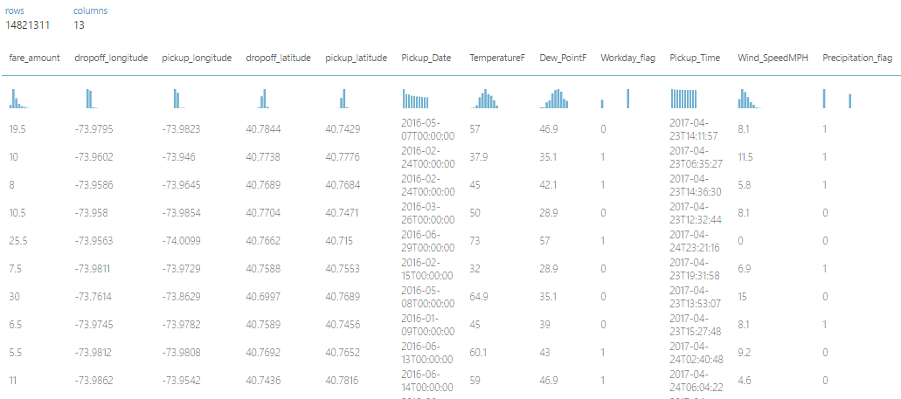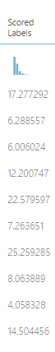

# FINE TUNING 4

* Increasing the number of hidden nodes improved the result (by 0.3784%)
* The rmse value earlier was **2.382844 which changed to 2.37906**
* We then tried increasing the hidden nodes to 200 and the learning rate to 0.007
* Below are our results

**Evaluated Model:**

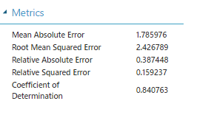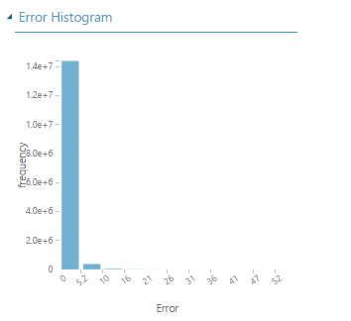

**Scored Value:**

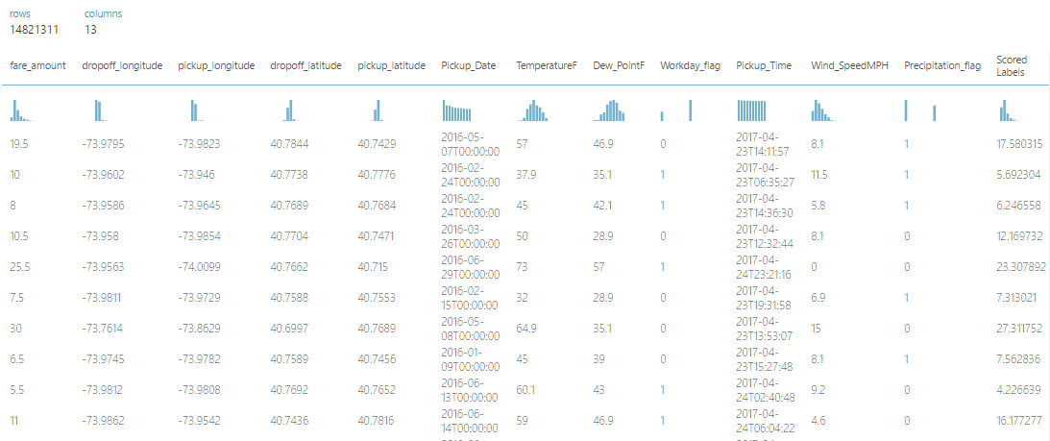

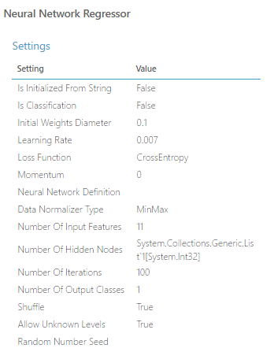

* We observed that increasing the learning rate value made the rmse worse
* We observed a rmse value of 2.426789 that was earlier **2.37906**

# FINE TUNING 5

* We finally changed the hidden nodes to 300, and the learning rate to 0.004
* **Evaluated Model**

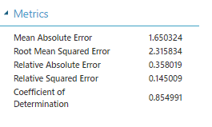

* **Scored Model**

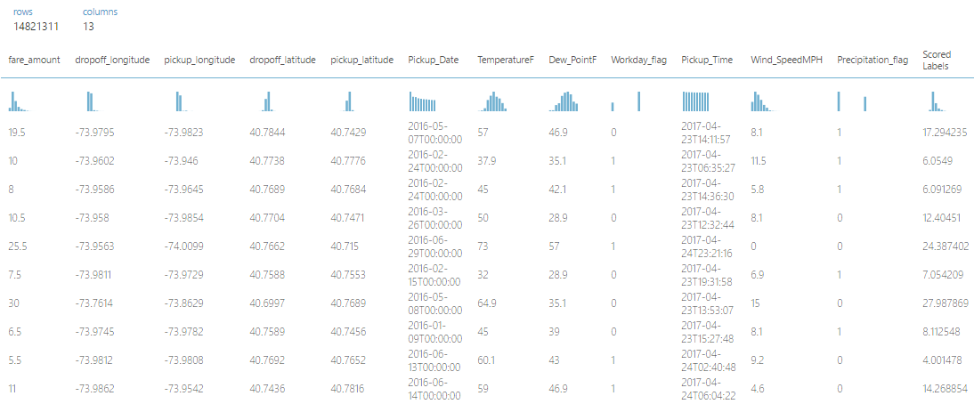

# The chosen one

|  |  |  |  |  |
| --- | --- | --- | --- | --- |
|  | Neural Network 1 | Neural Network 2 | Neural Network 3 | Neural Network 4 |
| Number of learning iterations | **100** | **100** | **100** | **100** |
| Number of hidden nodes | **100** | **200** | **300** | **400** |
| Learning Rate | **0.005** | **0.005** | **0.007** | **0.004** |
| RMSE | **2.382844** | **2.37906** | **2.426789** | **2.315834** |

## Web Service azure model



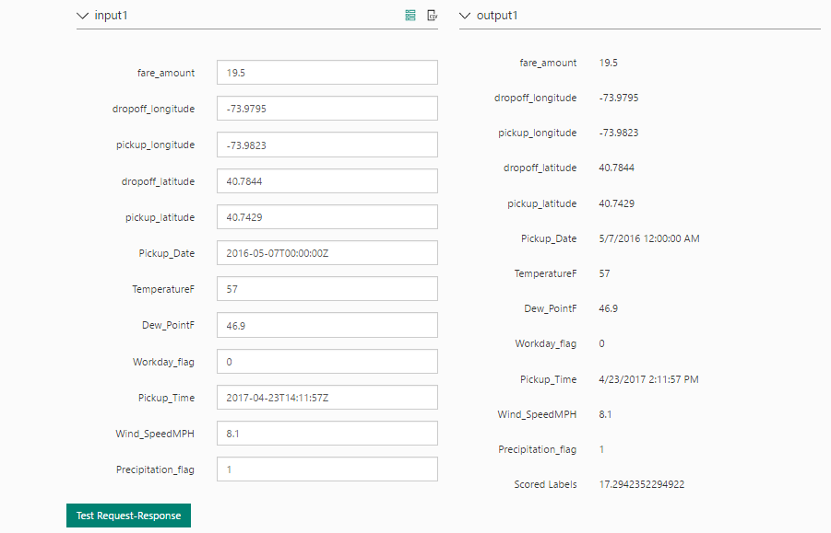

PREDICTING TRIP DISSTANCE

# azure mACHINE LEARNING EXPERIMENTS

The process to predict trip-time was as follows:

**Import & Combine Dataset**

“Add Rows” of individual months

#Total Size = 17 GB

**Select Required Columns**

Heuristics Based Feature Selection

**Filter Based Feature Selection**

Pearson Correlation;

# Of columns – 10,15

Split Data (0.8 Training, 0.2 Testing)

**Apply Regression Algorithms**

Boosted Decision Tree Regression

Neural Network Regression

Hyper Parameter Tuning & Reiterate

**Evaluate**

## IMPORT & COMBINE DATA

We used six months’ data to predict trip time.

Each of the dataset, (after scraping and cleaning), was uploaded individually to Azure.

We then used the Add Rows feature of the Machine Learning Studio to combine the individual files.

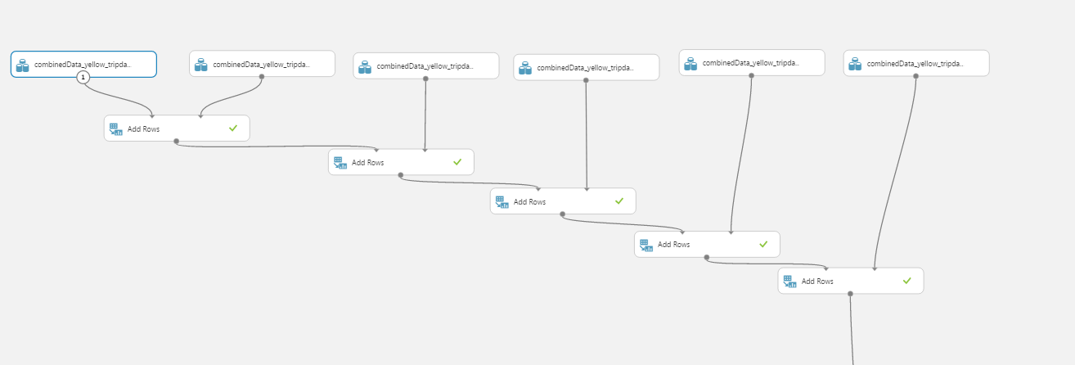

## HEURISTICS BASED FEATURE SELECTION

We did not pick the columns on the left. This was done as they were directly correlated with other selected feature (fare-amount) or they were insignificant for the trip-time prediction (Rate_code_id, number of passengers)

We then had 22 features in the filtered dataset.

## Filter Based Feature Selection

We then used Azure’s Filter Based Feature Selection to identify the columns in your input dataset that have the greatest predictive power.

* It provides a variety of statistical tests that you can apply, to determine the subset of features
* The columns are then ranked by their feature scores

We used **Pearson Correlation** as the metric to choose columns.

**Pearson Correlation**

Pearson’s correlation statistics or Pearson’s correlation coefficient is also known in statistical models as the **r** value. For any two variables, it returns a value that indicates the strength of the correlation.

Pearson's correlation coefficient is computed by taking the covariance of two variables and dividing by the product of their standard deviations. The coefficient is not affected by changes of scale in the two variables.

**With this parameter, we got the columns in the order of their importance to prediction as follows:**

|  |  |
| --- | --- |
| **Column Name** | **Importance** |
| dropoff_longitude | 0.112819 |
| dropoff_latitude | 0.107613 |
| workday_flag | 0.076523 |
| TemperatureF | 0.069045 |
| pickup_latitude | 0.066066 |
| pickup_longitude | 0.06351 |
| Time | 0.060272 |
| Dropoff_Date | 0.060188 |
| Pickup_Date | 0.060085 |
| Dew_PointF | 0.040012 |
| Hour_of_day | 0.036263 |
| Pickup_Time | 0.035807 |
| Day_of_week | 0.028643 |
| Humidity | 0.025024 |
| Sea_Level_PressureIn | 0.013685 |
| Precipitation_flag | 0.010994 |
| Wind_SpeedMPH | 0.006155 |
| WindDirDegrees | 0.005066 |
| VisibilityMPH | 0.002835 |

## 10 columns

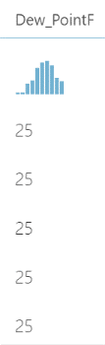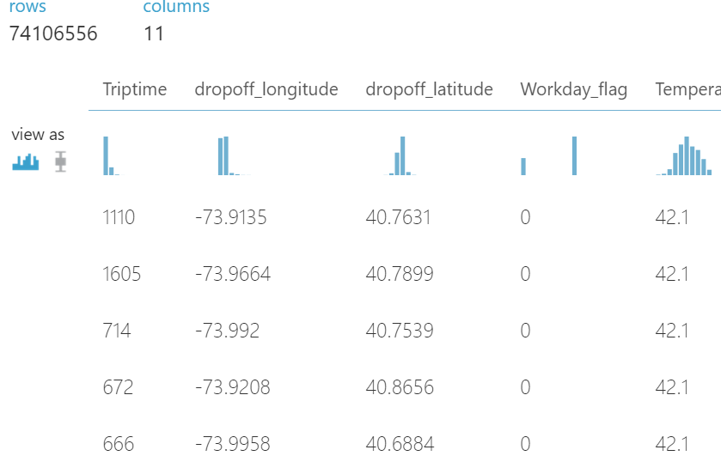

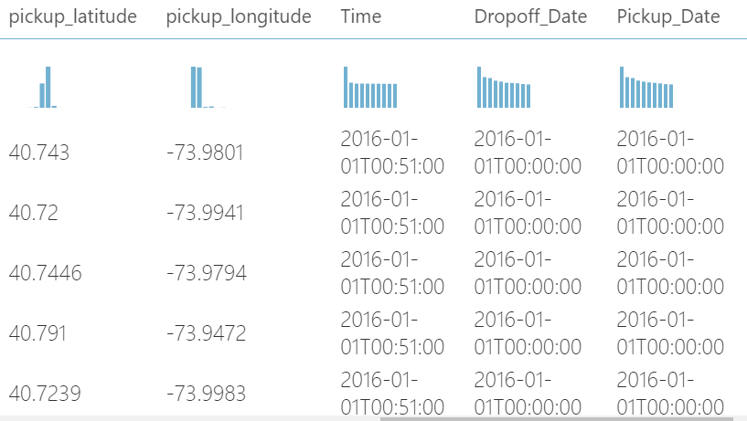

### Two Algorithms

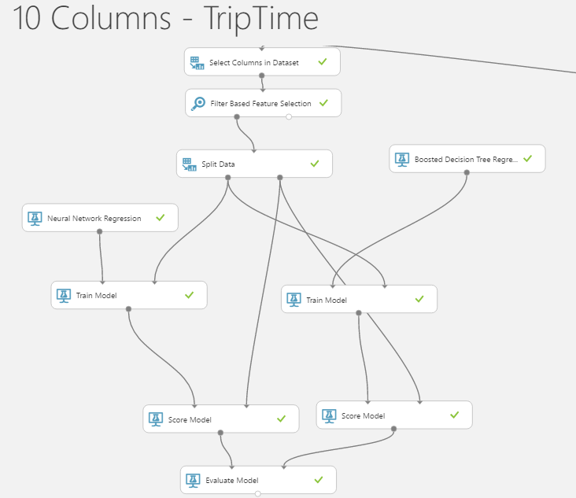

|  |  |
| --- | --- |
| SETTING | VALUE |
| Loss Function | Cross Entropy |
| Learning Rate | 0.005 |
| Data Normalizer | MinMax |
| # of Iterations | 100 |

Neural network regressor Boosted decision tree regressor

|  |  |
| --- | --- |
| SETTING | VALUE |
| Number Of Trees | 8 |
| Minimum Leaf Instances | 8 |
| Learning Rate | 0.2 |
| # Of Trees | 50 |

scored Dataset:

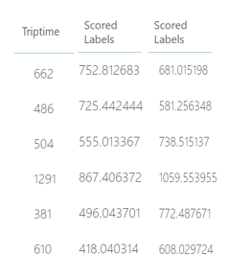

### evaluation

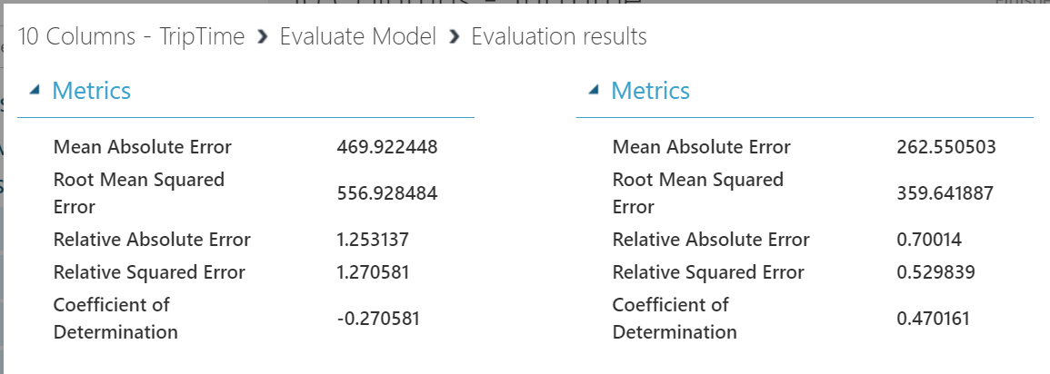

## 15 COLUMNS

With the same parameters like the previous one, we selected 15 instead of just 10 of the 22 columns to understand the importance of the number of columns:

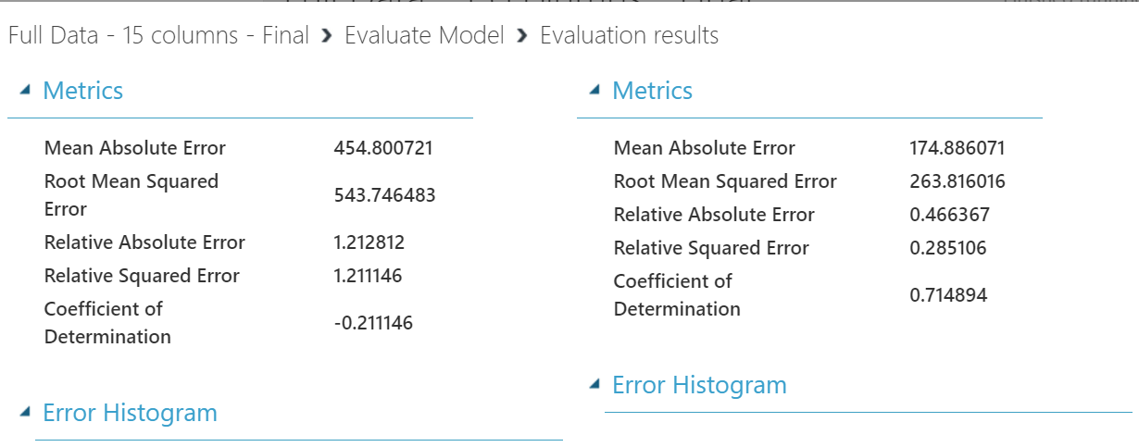

## how many columns to choose?

We saw that there was an improved RMSE with Random Forest Regressor with increase in number of columns.

#10 COLUMNS

|  |  |  |
| --- | --- | --- |
| **ALGORITHM** | **BOOSTED REGRESSION TREE** | **NEURAL NETWORK REGRESSOR** |
| MAE | 262.5050 | 469.922 |
| RMSE | 359.641 | 556.92 |
| RAE | 0.7004 | 1.2531 |
| RSE | 0.5298 | 1.2705 |
| COEFFICIENT OF DETERMINATION | 0.4701 | -0.2705 |

#15 COLUMNS

|  |  |  |
| --- | --- | --- |
| **ALGORITHM** | **BOOSTED REGRESSION TREE** | **NEURAL NETWORK REGRESSOR** |
| MAE | 174.88 | 454.800 |
| RMSE | 263.81 | 543.7464 |
| RAE | 0.4663 | 1.2123 |
| RSE | 0.2851 | 1.211 |
| COEFFICIENT OF DETERMINATION | 0.7148 | -0.2111 |

Hence, parameter was further tuned for Random Forest Regressor to get the best model.

## Fine tuning

We decided to go ahead with the Random Forest model for triptime prediction.

The original model, run for 50 trees, was then tuned to check for better models.

Boosted decision tree regressor

|  |  |  |  |  |
| --- | --- | --- | --- | --- |
| SETTING | VALUE – I | VALUE-II | VALUE-III | VALUE-IV |
| Max # of Leaves | 8 | 20 | 25 | 25 |
| Minimum Leaf Instances | 8 | 10 | 15 | 15 |
| Learning Rate | 0.2 | 0.2 | 0.2 | 0.25 |
| # Of Trees | 50 | 100 | 200 | 500 |

|  |  |  |  |  |
| --- | --- | --- | --- | --- |
| **ALGORITHM** | **MODEL 1** | **MODEL 2** | **MODEL 3** | **MODEL 4** |
| MAE | 174.88 | 185.9495 | 171.320 | 160.64 |
| RMSE | 263.81 | 270.6199 | 254.2419 | 242.2346 |
| RAE | 0.4663 | 0.5349 | 0.4928 | 0.4621 |
| RSE | 0.2851 | 0.3479 | 0.3070 | 0.2787 |
| COEFFICIENT OF DETERMINATION | 0.7148 | 0.6520 | 0.692919 | 0.72124 |

MODEL 2 MODEL 3

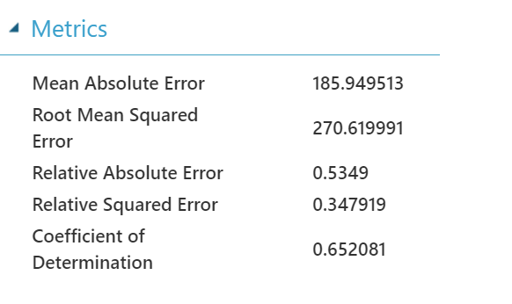

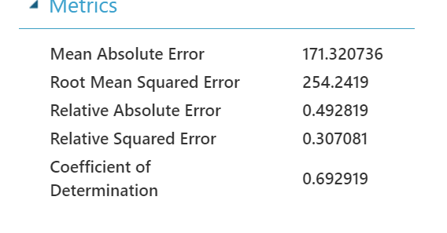

# **Classification**

1. We calculated the count of pickups for each group of location, day and hour or day
2. We then bucketed the count of pickups into 3 categories ( 0 to 474 🡪 92 percentile, 474 to 726 🡪 95 percentile, and greater than 726) and named it “pickup_count_category”
3. We divided the locations into 28 buckets of ~ 9 square KM each. To do this, we rounded the coordinates upto 2 decimal points which gave us the accuracy of the location upto 1.1 KM.
4. To find the location with the maximum pickups in the hour of the day, we predicted the “pickup_count_category” for each of the zones. We store the nyc_zone for which the pickup_count_category was predicted as 3. These zones are predicted to have high number of pickup counts in that particular hour.
5. Algorithms and scores:

|  |  |  |  |  |  |  |  |  |  |  |  |  |
| --- | --- | --- | --- | --- | --- | --- | --- | --- | --- | --- | --- | --- |
| Multiclass Decision Forest |  |  |  | Actual 1 | | | Actual 2 | | | Actual 3 | | |
| Decision Trees | Max Depth of Decision Trees | Random Splits Per Node | Minimum Samples per Leaf Node | Predicted 1 | Predicted 2 | Predicted 3 | Predicted 1 | Predicted 2 | Predicted 3 | Predicted 1 | Predicted 2 | Predicted 3 |
| 100 | 64 | 128 | 1 | 97.7 | 0.5 | 1.8 | 71.2 | 4.3 | 24.5 | 36.1 | 4.3 | 59.6 |
| 400 | 128 | 128 | 2 | 97.8 | 0.4 | 1.8 | 71.2 | 4.2 | 24.6 | 36 | 4.3 | 59.7 |
|  |  |  |  |  |  |  |  |  |  |  |  |  |
| Multiclass Neural Network |  |  | Actual 1 | | | Actual 2 | | | Actual 3 | | |  |
| Hidden Nodes | Learning Rate | Learning Iterations | Predicted 1 | Predicted 2 | Predicted 3 | Predicted 1 | Predicted 2 | Predicted 3 | Predicted 1 | Predicted 2 | Predicted 3 |  |
| 1000 | 0.1 | 100 | 97.8 | 0 | 2.2 | 68.9 | 0 | 31 | 29.6 | 0.1 | 70.3 |  |
| 1000 | 0.05 | 128 | 98 | 0 | 2 | 71.5 | 0 | 28.5 | 35.7 | 0 | 64.3 |  |
| 100 | 0.1 | 128 | 97.5 | 0 | 2.5 | 68.6 | 0.1 | 31.4 | 30.8 | 0 | 69.1 |  |
| 100 | 0.5 | 128 | 97.8 | 0 | 2.2 | 75.1 | 0 | 24.9 | 41.1 | 0 | 58.9 |  |
| 100 | 0.5 | 64 | 97.9 | 0 | 2.1 | 74.2 | 0.1 | 25.7 | 36.9 | 0.1 | 63.1 |  |
| 100 | 0.1 | 64 | 97.8 | 0 | 2.2 | 71.6 | 0 | 28.4 | 35.1 | 0 | 64.9 |  |
| 100 | 0.1 | 32 | 97.9 | 0 | 2.1 | 73.4 | 0 | 26.6 | 37.3 | 0 | 62.7 |  |
| 1000 | 0.01 | 200 | 98.1 | 0 | 1.9 | 71.2 | 0 | 28.8 | 35.2 | 0 | 64.8 |  |
|  |  |  |  |  |  |  |  |  |  |  |  |  |
|  |  |  |  |  |  |  |  |  |  |  |  |  |
| Multiclass Decision Jungle |  |  |  | Actual 1 | | | Actual 2 | | | Actual 3 | | |
| Decision DAGs | Max Depth of Decision DAGs | Max Width of Decision DAGs | Optimization steps per decision DAG layer | Predicted 1 | Predicted 2 | Predicted 3 | Predicted 1 | Predicted 2 | Predicted 3 | Predicted 1 | Predicted 2 | Predicted 3 |
| 8 | 32 | 128 | 2048 | 98.5 | 0 | 1.5 | 74.5 | 0 | 26 | 38.5 | 0 | 61.5 |
|  |  |  |  |  |  |  |  |  |  |  |  |  |
| Multiclass Logistic Regression |  |  |  |  |  |  |  |  |  |  |  |  |
| Actual 1 | | | Actual 2 | | | Actual 3 | | |  |  |  |  |
| Predicted 1 | Predicted 2 | Predicted 3 | Predicted 1 | Predicted 2 | Predicted 3 | Predicted 1 | Predicted 2 | Predicted 3 |  |  |  |  |
| 99.7 | 0 | 0.3 | 98.7 | 0 | 1.3 | 97.2 | 0 | 2.8 |  |  |  |  |

1. We created Azure ML web service with the selected model and interacted with it using Java – Spring Web Application.

*Q. Would you recommend using this model?*

*A. We would not recommend our model for prediction of maximum pickups because currently we are making 28 calls to the api to get the results for each zone, and then finding which zones will have more than 726 pickups in the particular hour of the day. Ideally there should have been just 1 api call which should have predicted which zone out of 28 will have maximum pickups. Also, the accuracy of prediction is ~70 percent.*

*Calling the api 28 times instead of 1, would increase the burden on the server and hence increase the cost of the application, which in our opinion would not be good for getting accuracy of 70 percent.*

# Data Analysis Using Jupyter Notebook

## NYC TAXI (YELLOW) TRIPS – PICK-UP AND DROP-OFF

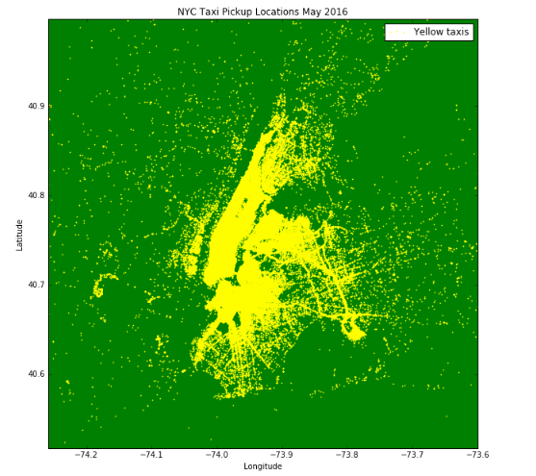

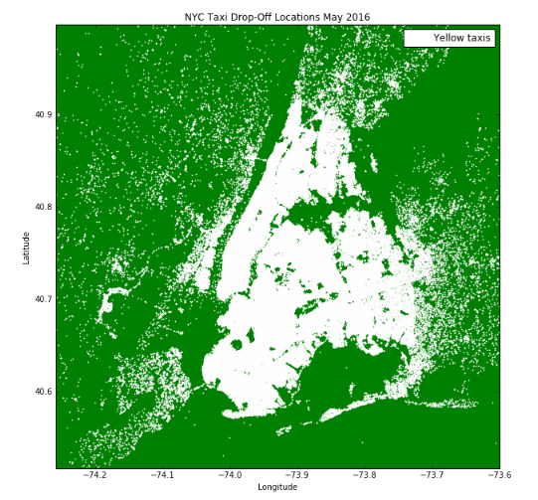

## Conclusions

In our dataset, every month has over four million trips made. To understand and give a high level view of our pickups and drop off, we plotted every pick-up and drop off.

Although our main pickup points are concentrated to Manhattan, Broadway, Time Square , etc, the drop-offs are spread out.

## NYC TAXI (YELLOW) TRIPS – tip and total amount data

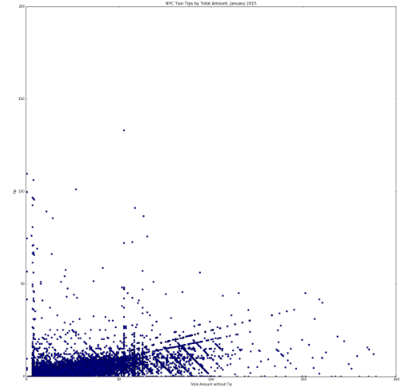

## Conclusions

* This graph depicts the total amount by the tip paid to the drivers
* More than 70% fare amounts are between 0-30 USD

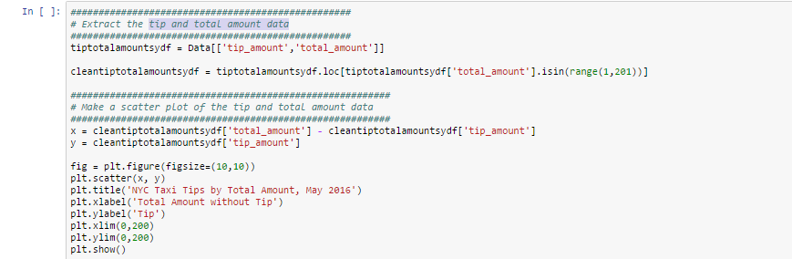

## TAXI RIDES AGAINST EXTREME WEATHER CONDITIONS (MAY AND JUNE 2016)

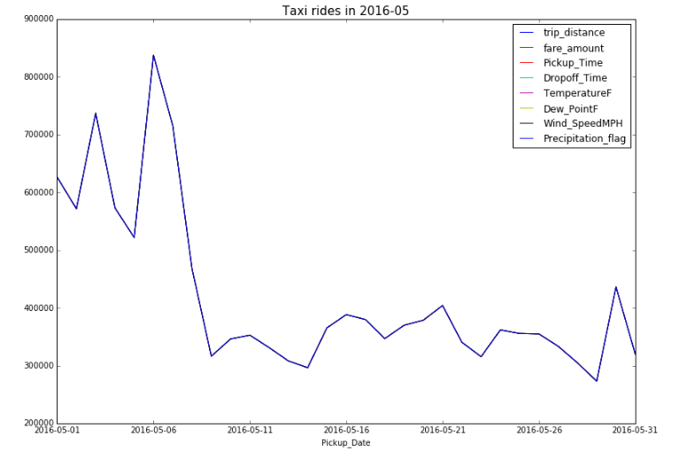­­

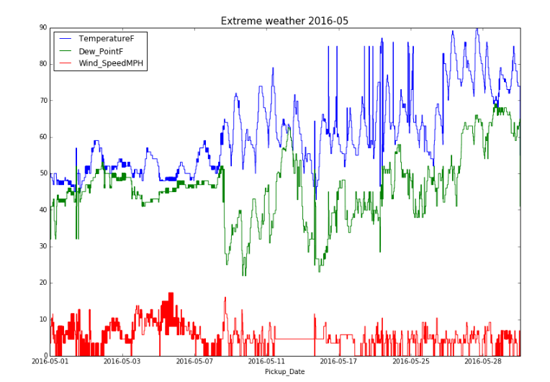

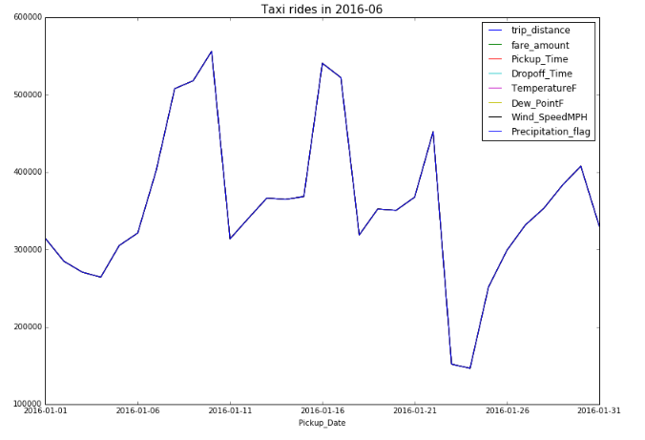

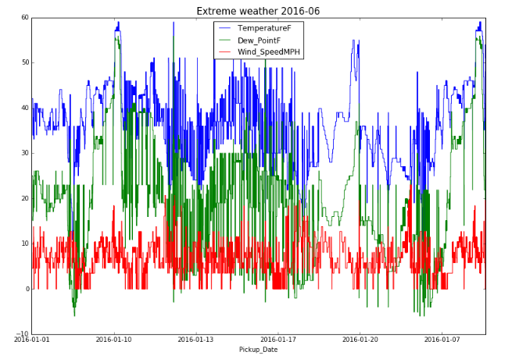

## CONCLUSIONS

* We observed that the taxi rides in May was higher when the weather conditions were bad.
* The charts show that the number of taxi rides were the highest during cold temperature

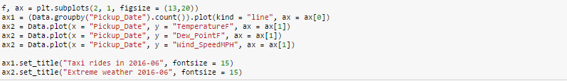

## FARE AMOUNT, TRIPTIME, PASSENGER COUNT USING CARTO MAPS

<https://pptaj.carto.com/dashboard>

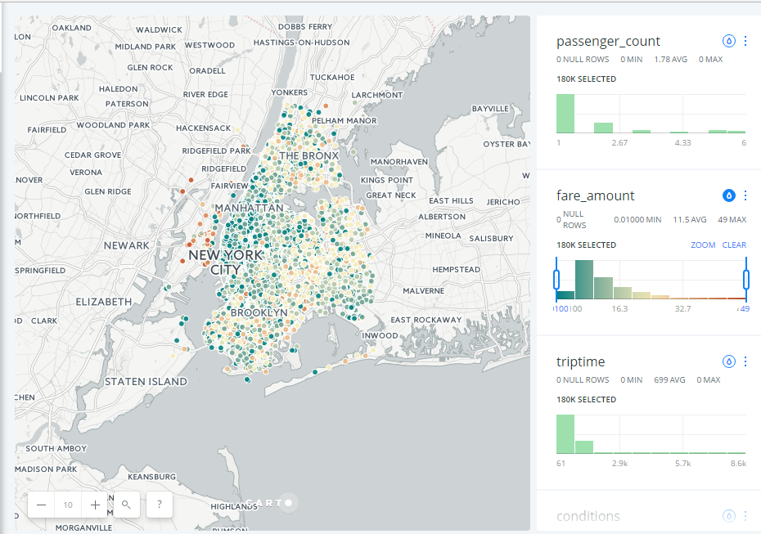

## CONCLUSIONS

* As demonstrated in the map, the fare amount is grater in busier areas such as Manhattan

## FARE AMOUNT, TRIPTIME, PASSENGER COUNT USING CARTO MAPS

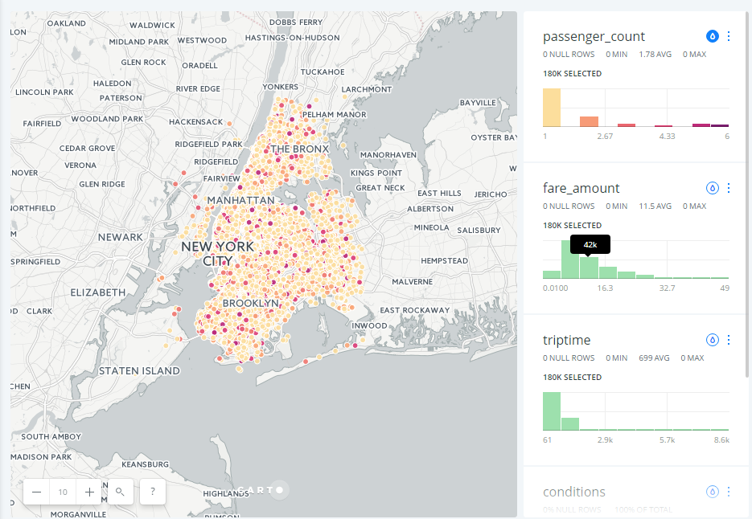

## CONCLUSIONS

* The passenger count is mostly 1 in almost all areas and most rides

## TRIP-TIME USING CARTO

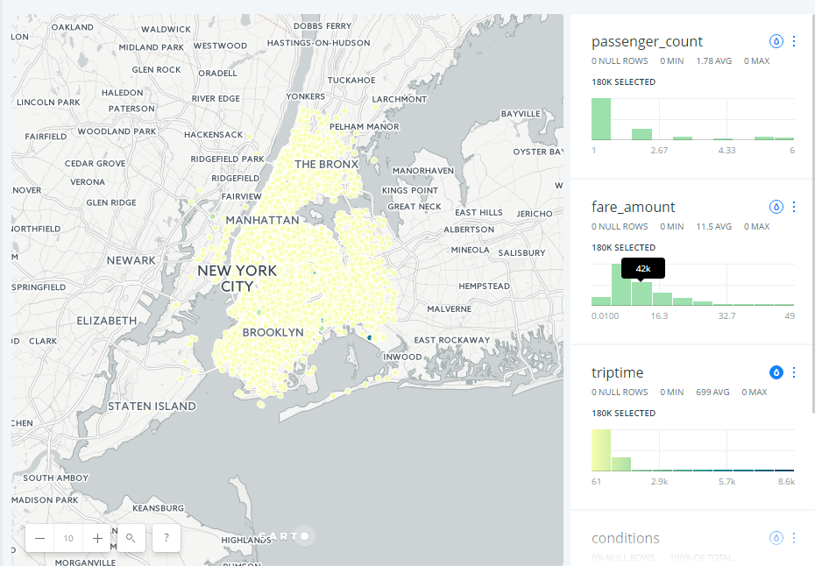

## CONCLUSIONS

* Trip-time is mostly short for most rides expect one or two in the outskirts

## WEATHER CONDITIONS USING CARTO

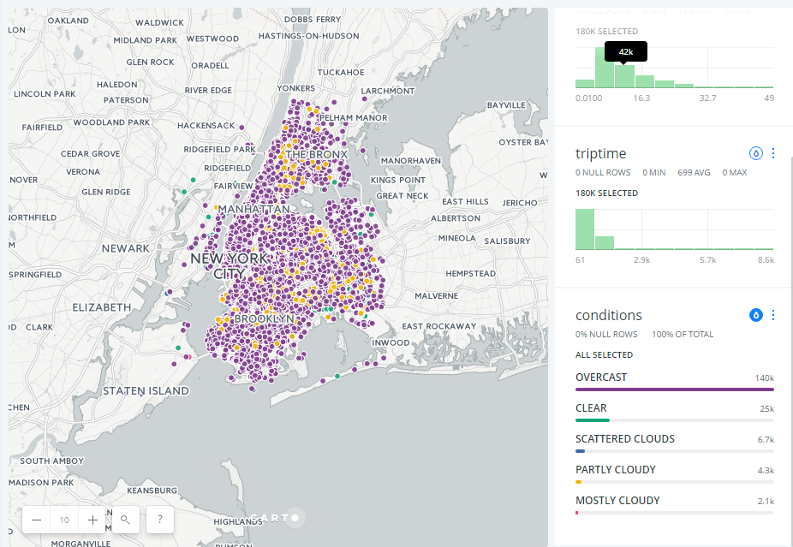

## CONCLUSIONS

* The weather in NYC is mostly cloudy as we know in the month of Jan

## TRIP-DISTANCE

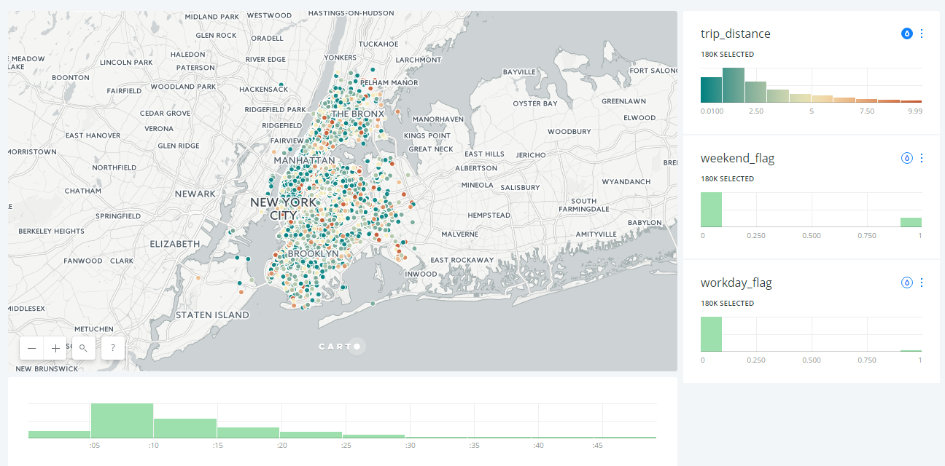

## CONCLUSIONS

* Trip-distance is mostly short for most rides

## CLASSIFIED AREAS USED FOR PREDICTING BUSIEST AREAS FOR DRIVERS

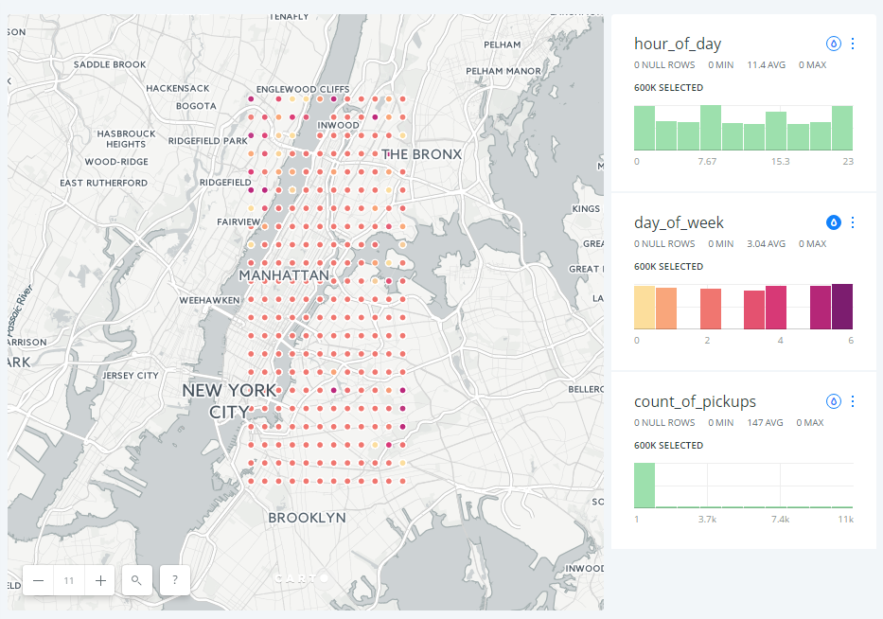

## CONCLUSIONS

* This map depicts the 28 regions that we’ve considered
* It also shows the pick-ups across different areas categorized by the day of the week

## CLASSIFIED AREAS USED FOR PREDICTING BUSIEST AREAS FOR DRIVERS

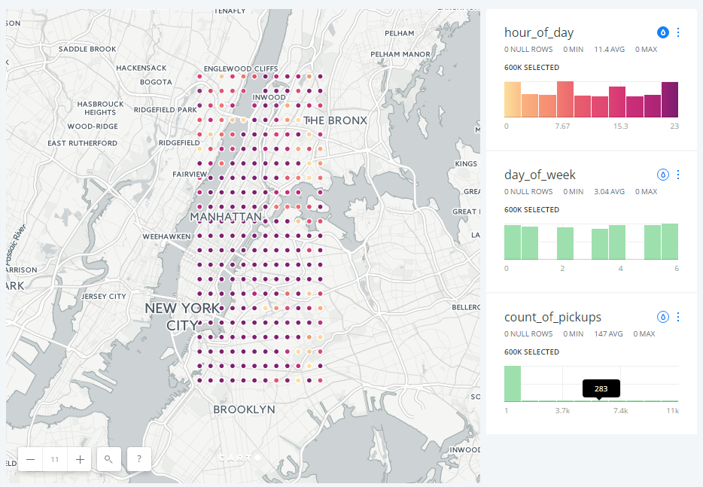

## CONCLUSIONS

* This map depicts the 28 regions that we’ve considered
* It also shows the pick-ups across different areas categorized by the hour of the day

# TIP AMOUNT HOT-SPOTS USING ARCGIS (2015 data)

<https://adsproject.maps.arcgis.com/home/content.html> 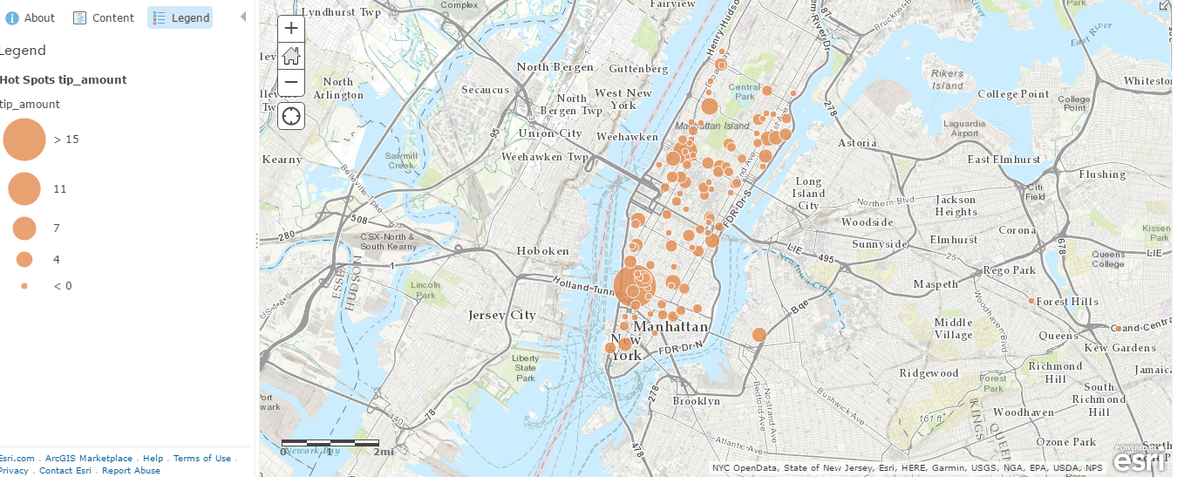

## CONCLUSIONS

* We can see that the drivers are tipped more in places near the Greenwich Village and the Upper side of Manhattan

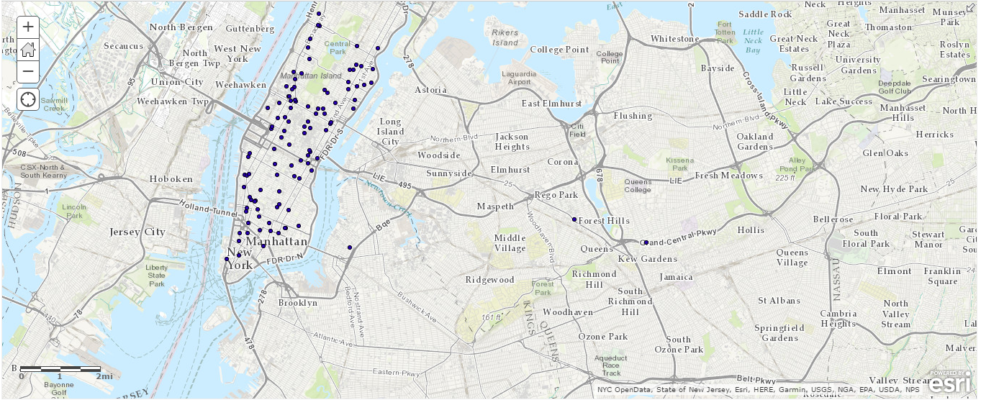

## CONCLUSIONS

* The map shows areas in NYC that have cabs picking up up to 5 p

# DEMO OUTPUTS

**OUR OUTPUTS AND GOOGLE MAPS/ UBER COMPARISONS**

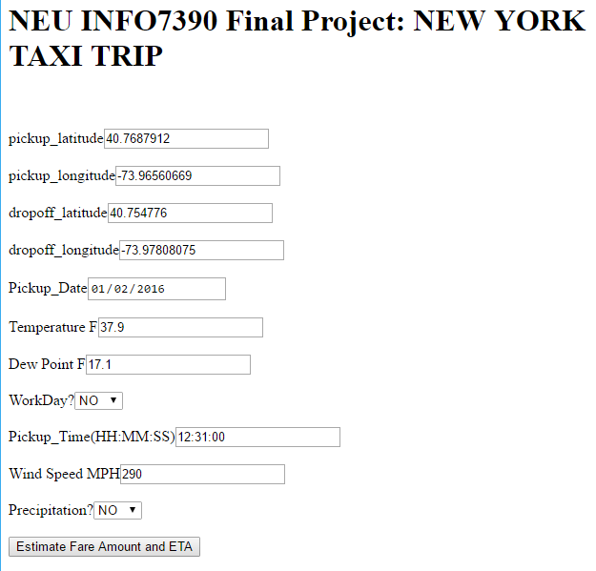

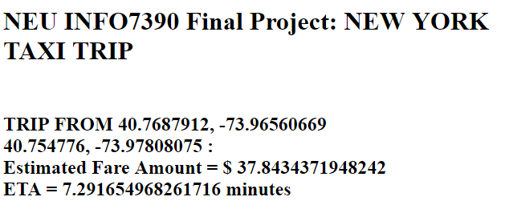

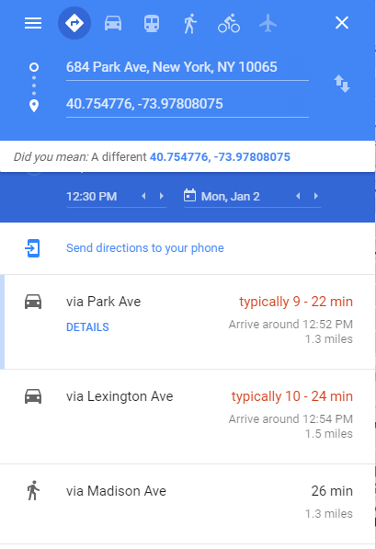

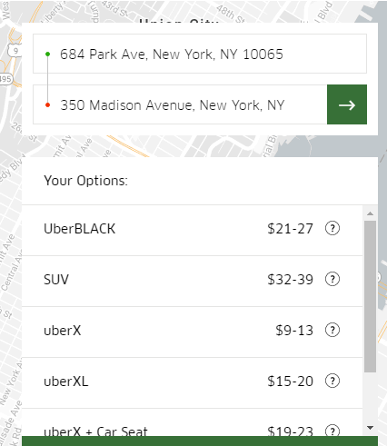

1. **CURRENT**

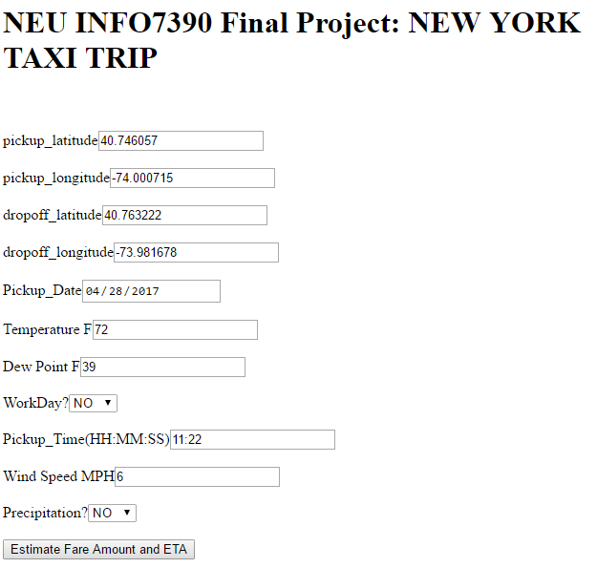

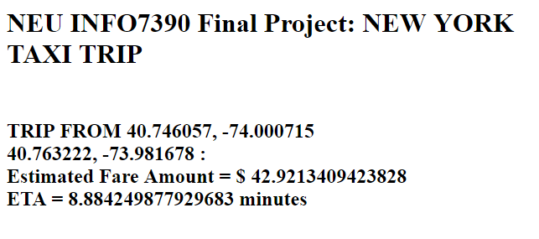

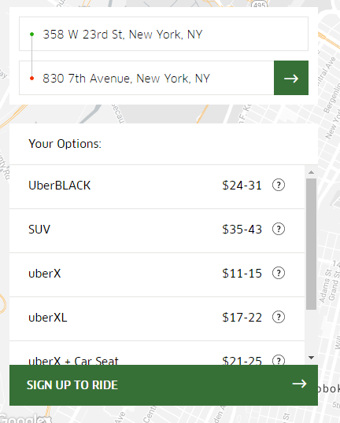

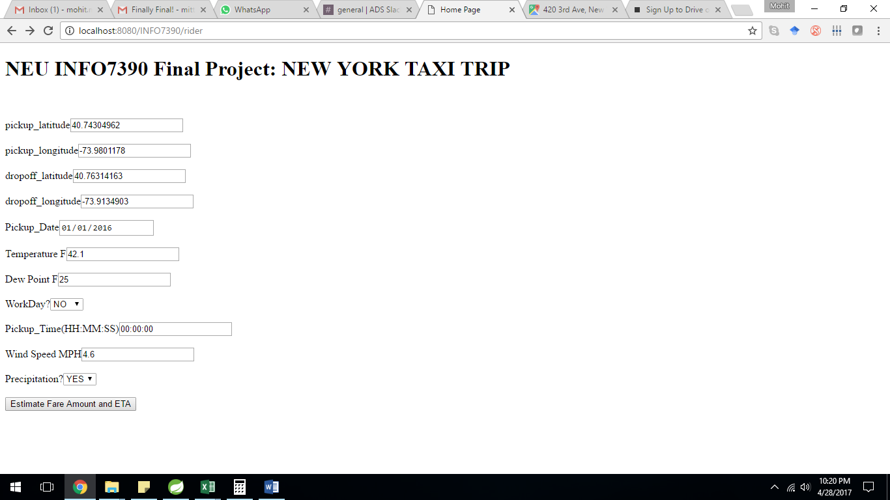

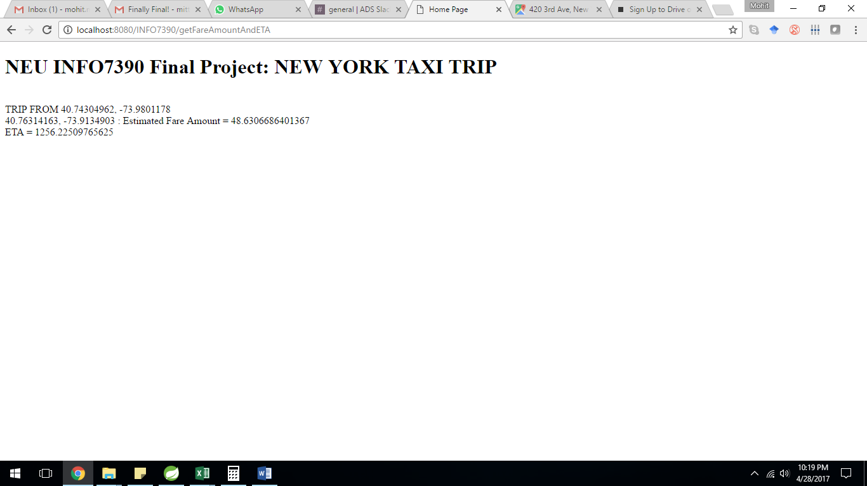

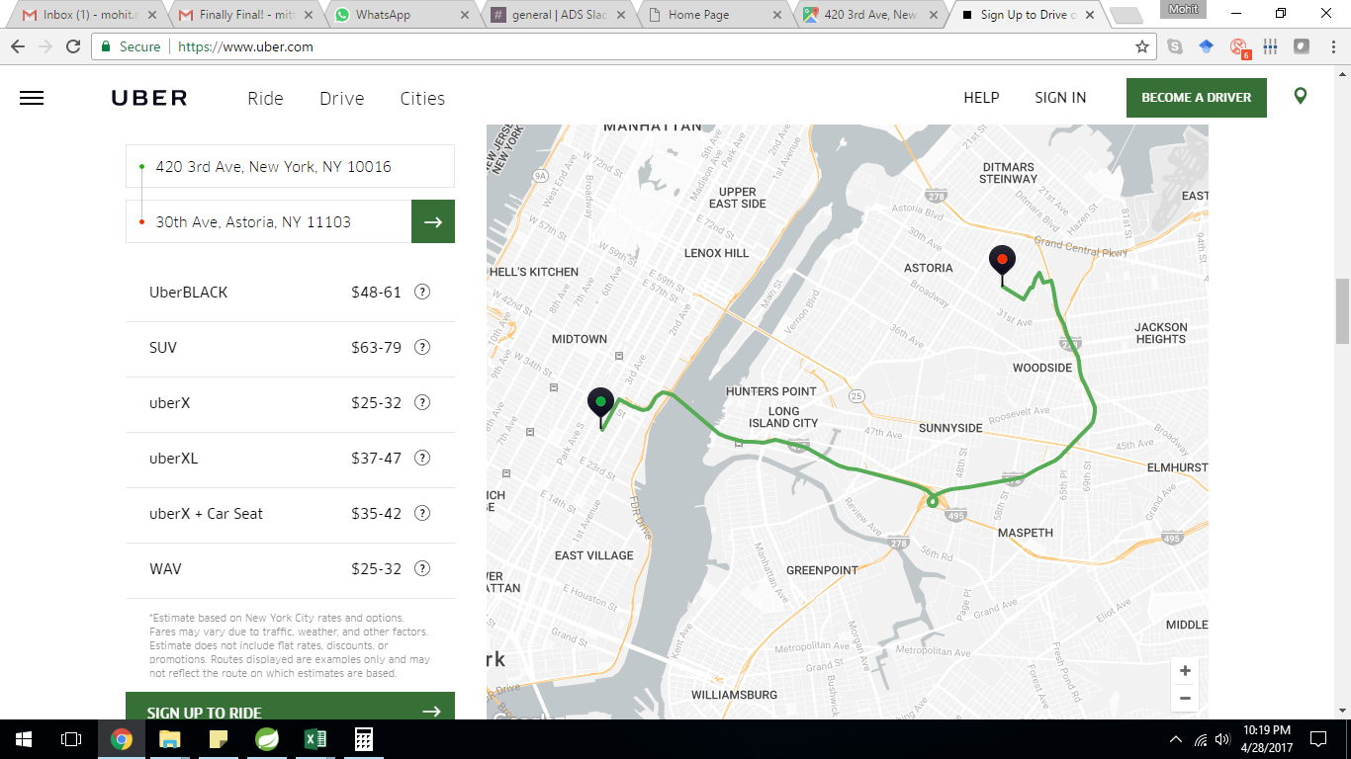

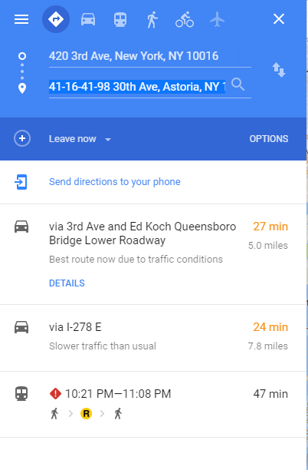

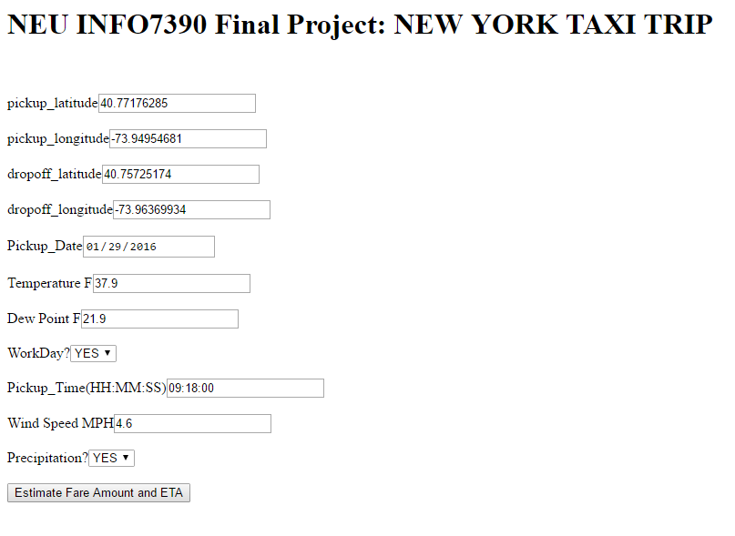

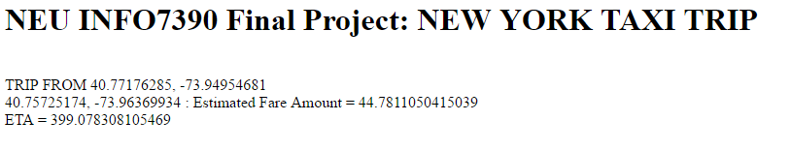

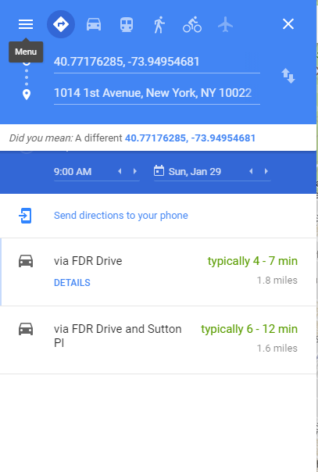

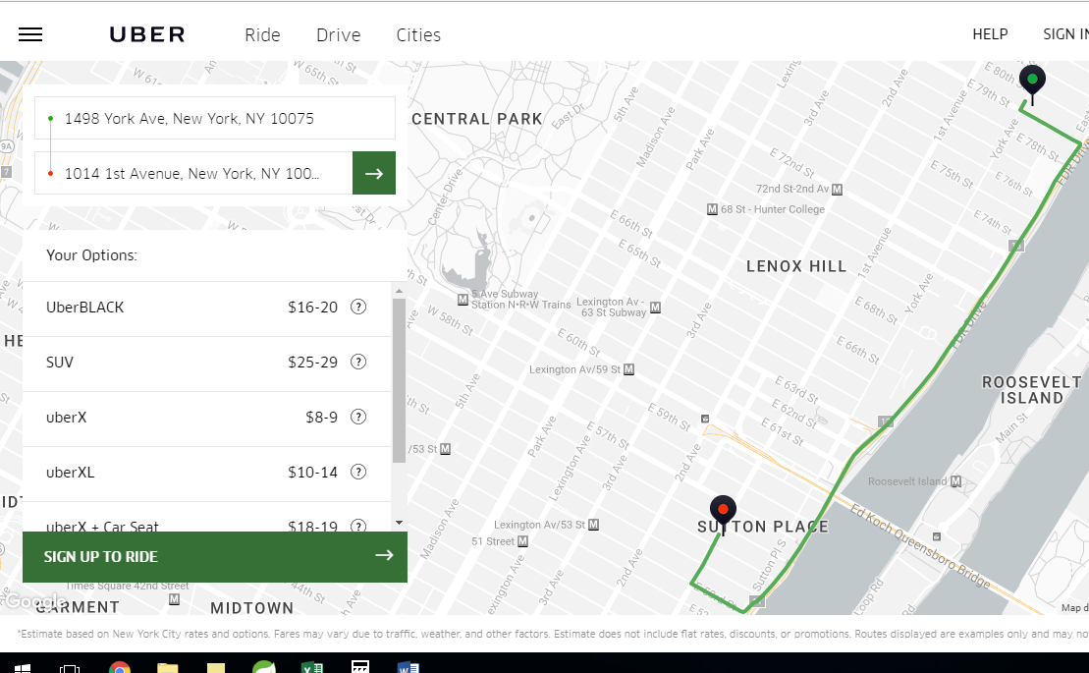

1. **Max Pickup Location**

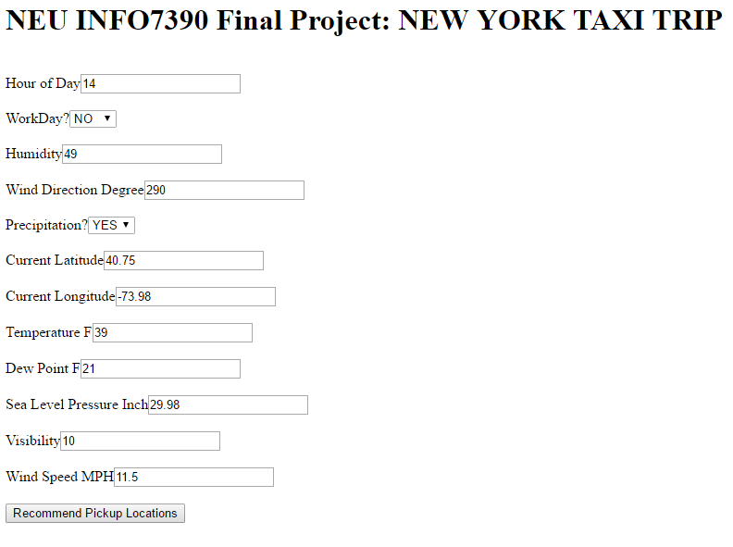

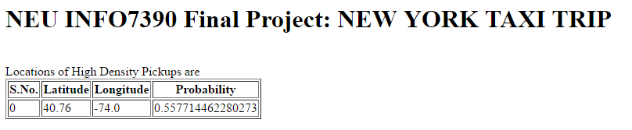

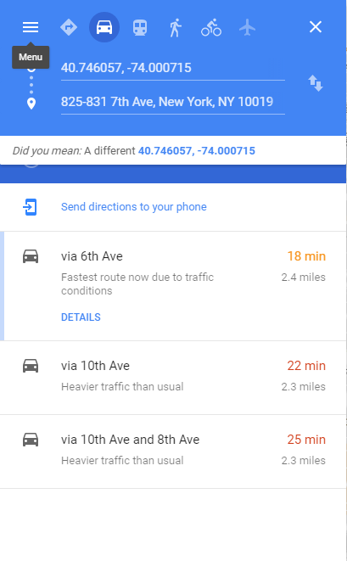

**Thank You**